Supplemental Stories for chanukah
Volume 6, Issue 15 5 Teves 5775/ December 27, 2014
Printed L’illuy nishmas Nechama bas R’ Noach, a”h
Our Miraculous Escape From The 2017 California Firestorm
By Rabbi Shraga Simmons

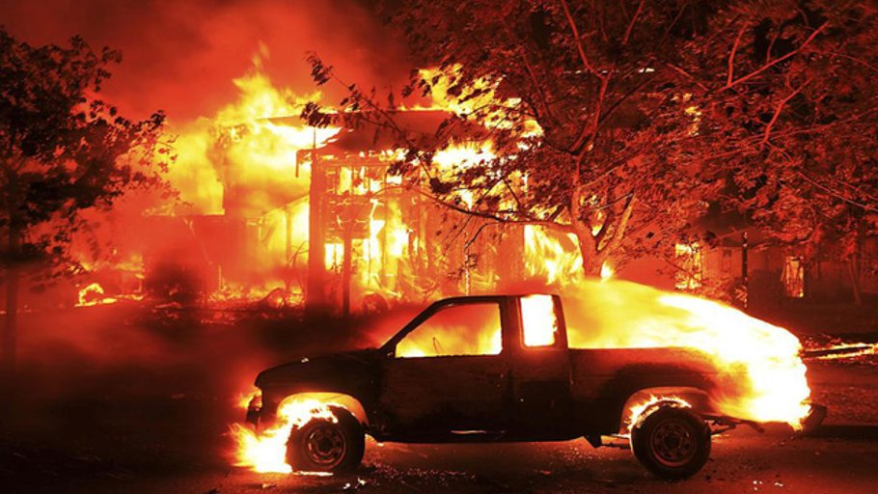
The Rosenthal family just barely made it out alive. An Aish.com exclusive.

From the window of his office in Davis, California, Justin Rosenthal sees thick plumes of smoke from the “Camp” wildfire now ravaging northern California. With at least 70 people dead and 6,000 homes destroyed, this eerily echoes Justin’s own harrowing escape from a northern California firestorm just one year ago.
It was Sukkot 2017, with Justin and his family enjoying a holiday dinner in their sukkah in Santa Rosa, a city of 150,000, near the Napa wine region. “That evening, we had a poignant family discussion about the sukkah as a temporary dwelling,” Justin tells Aish.com. “We spoke about the bamboo roof symbolizing the transient nature of materialism. And we talked about what is truly important: faith, love, and family.”

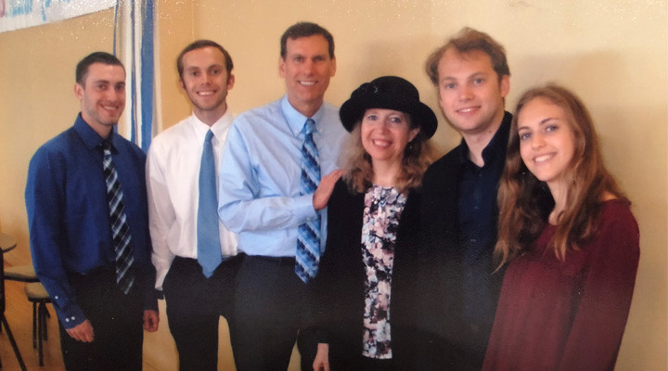The Rosenthals (left to right: Elias, Ari, Justin, Shacharit, Daniel, Moriah)

The winds were intensely strong that night, so the Rosenthal family – Justin, his wife Shacharit, 18-year-old twins Ari and Elias, and 16-year-old daughter Moriah – went back inside their house. When a power blackout hit around midnight – due to high winds impacting power lines – everyone went to sleep.
At 3:30 am, Eli heard a fire truck roaring through the neighborhood, sounding an alert: “Evacuate NOW!” It was to be the final warning.
One gaze out the window confirmed the worst. A downed electric transformer had ignited the parched landscape suffering one of the worst droughts in California history. Winds of 60 mph fanned the flames and carried them at high speed. Emergency personnel were caught by surprise, leaving residents virtually no time to escape.
Eli quickly woke up the others and there no time to take anything – heirlooms, photos, or IDs. Within 25 seconds – with no electricity, in the pitch dark – the Rosenthals made their way downstairs to the garage. “We touched the garage door and could feel the intense heat,” Justin says. “But the only option, if we didn't want to die in this inferno, was to make a run for it.”
With an electric garage door – and no electricity – the escape almost never started. Fortunately, Justin knew to pull the emergency cable, but he first needed to find it in the dark, then contend with manually lifting the heavy garage door.
“We opened the door and saw the entire neighborhood was an inferno,” Justin says.
To compound the situation, the entrance to their long driveway had an electric security gate. Without the key for manually opening the gate, they were trapped. “We made a mad dash back into the house,” Justin says. They groped around in the dark to find the right drawer, and as precious moments ticked by, they found the key.
Shacharit quickly unlocked the gate, jumped back in the car, and the Rosenthals pulled out – the flames mere seconds from igniting their house.
Justin focused on navigating the obstacle course of flaming tree branches falling in the road, along with thick smoke and walls of flame that made it nearly impossible to see. “We didn't think we were going to make it,” he says. “As we drove through the flames, we all said Shema.”
They called Justin’s elderly parents who were living in a nearby retirement community. Finally, after many attempts, they answered the phone. They’d had no warning whatsoever, and already some of the community’s buildings were on fire. “By the time we arrived, it was impossible to reach my parents through the wall of flames,” Justin recalls. “So my parents stayed shelter in place. We had no choice but to drive away. We lost contact with them and didn't know if they'd survived.” (They did.)
The Rosenthals, pajamas and all, headed south to Berkeley, where Justin’s sister helped them decompress. Justin reports: “The sun was coming up and the first thing the kids wanted to do was find a sukkah, shake the lulav, and thank G-d for having survived.”

Prized Possessions
When the Rosenthals went back to examine the wreckage, they discovered that not all their neighbors had survived. In Santa Rosa alone, 22 people were dead, 4,500 homes destroyed, 100,000 people displaced, and untold billions in damage. “Many of the deaths occurred with people inside their garage, unable to escape,” Justin says. “Either they didn't know how to use the emergency cable, or didn't have the strength to lift the garage door.”
Only one item miraculously survived the inferno: the Rosenthals’ etrog.
The Rosenthals’ home was completely obliterated. From the intensity of the heat, their second car had completely melted. Only one item miraculously survived the inferno: the Rosenthals’ etrog. Discovered unscathed amidst a totally melted and burned sukkah, it symbolized the Jewish people’s heart and faith during challenging times.
The Rosenthals’ daughter Moriah had her own incredible experience. Having attended Camp Stone in Pennsylvania, she’d participated in an educational program where she made a list of her most meaningful possessions, ready to take anywhere, anytime. Justin explains: “They described this as a personal ‘Moshiach Bag,’ in the sense of being ready to leave everything behind on a moment’s notice, to greet Moshiach.”

Entrance to the Rosenthals’ home in Santa Rosa

Moriah took that lesson to heart, and upon returning home from camp, packed a backpack with her diary, a tzedakah box, book of Psalms, prayer book, and a few family photos. She then hung it on her bedroom door. Then, on the night of the fire, in those fateful moments before rushing out, Moriah grabbed her Moshiach Bag, which (along with the tefillin her brother Ari grabbed) became the family's most important possessions. Moriah’s “essential items” now occupy a prominent place on the Rosenthals’ living room mantel.
“When the moment comes, what will you grab?” Justin asks.

Family Faith

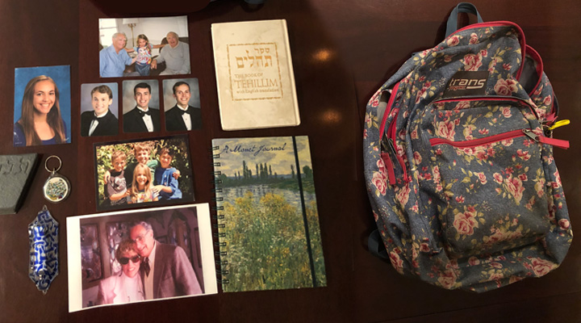Saved from the blaze: Moriah’s Moshiach Bag and its contents.

Justin was raised as a non-religious Jew, “in synagogue only once, for my Bar Mitzvah,” he says. When he met Shacharit, who had grown up Reform and become observant, Justin needed to catch up on Judaism. So in the mid-1990s, he attended Aish HaTorah’s Discovery seminar in San Francisco. “My reaction was: Where has this been my whole life?” Justin says. “So I became an ardent reader of Aish.com and haven't stopped since. I’ve always shared the content with my children. Aish.com has made a world of difference.”
Prior to the fire, the Rosenthal children attended public school, while maintaining a strong Jewish identity. “They really love Judaism,” Justin says. “At high school they started a Jewish Club to teach other kids.”
Events of the past year have greatly impacted the Rosenthal’s Jewish life. After the fire, they relocated to Oakland, where they’d already been involved with Beth Jacob Congregation. Shul members opened their homes, and the local Jewish high school immediately accepted the children, infusing the family’s Jewish life. Today Eli is studying at the Aish Gesher program in Jerusalem. His twin brother Ari attends Yeshivat Har Etzion and plans to become a rabbi.

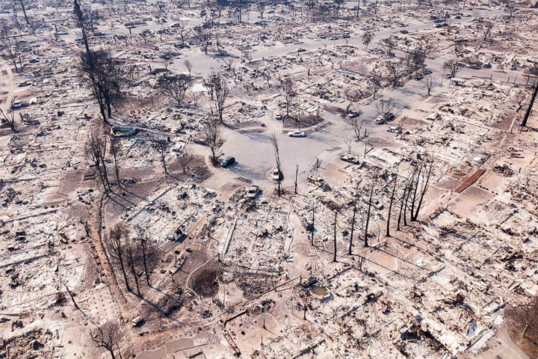Total devastation: aerial view of a cul-de-sac in Santa Rosa, October 2017

Ongoing Crisis
Today, 15 months after the fire, Santa Rosa is a city in crisis. The flames were so intense that they melted the plastic water pipes embedded three feet underground – destroying plumbing infrastructure and releasing chemicals into the soil and water supply. The federal government has since removed much of the toxic soil, leaving massive empty pits where beautiful homes once stood.
The firestorm is never from the minds of Justin and Shacharit who speak publicly, sharing their experience and promoting home safety. "In a group of 100 people, perhaps one knows how to open the garage manually,” Justin says. “In event of a natural disaster, we're woefully unprepared."
Besides the need for flashlights, smoke detectors, and an evacuation plan, Justin recommends making electronic copies of important documents and uploading them to the cloud. It’s a lesson he discovered too late. “All our documents were destroyed, and we had to spend countless hours in government offices establishing our own identification,” he laments.
The 2017 Santa Rosa fire was not the first for Justin’s parents. In 1991 they were living in Oakland when a huge firestorm broke out that killed 25 people and destroyed 3,000 homes. “Most of the deaths occurred on my parents' street, and they were the last ones to get out alive,” Justin says. “The smoke was so thick that they couldn't tell which way was downhill. So my father put the car in neutral and let gravity guide them. He needed to keep banging into the curb to gauge where he was going.”
As for the Rosenthals’ future, they still await settlement from the insurance company. “With so many natural disasters, these companies are facing financial ruin,” Justin says. “The concern is that they will become insolvent and not pay anything out.”
Today Justin works in Davis, California, where the current inferno has claimed over 50 lives and 8,800 structures, making it the deadliest and most destructive wildfire in the state's history. One of Justin’s colleague's is searching for her missing family; her uncle is already declared dead.
Every day, Justin is grateful for his family’s survival. “Had my son not heard the warning,” he says, “we would have slept right through it.”

Reprinted from the November 15, 2018 website of Aish.com

Out of Ghetto Streets
By Allan Levine

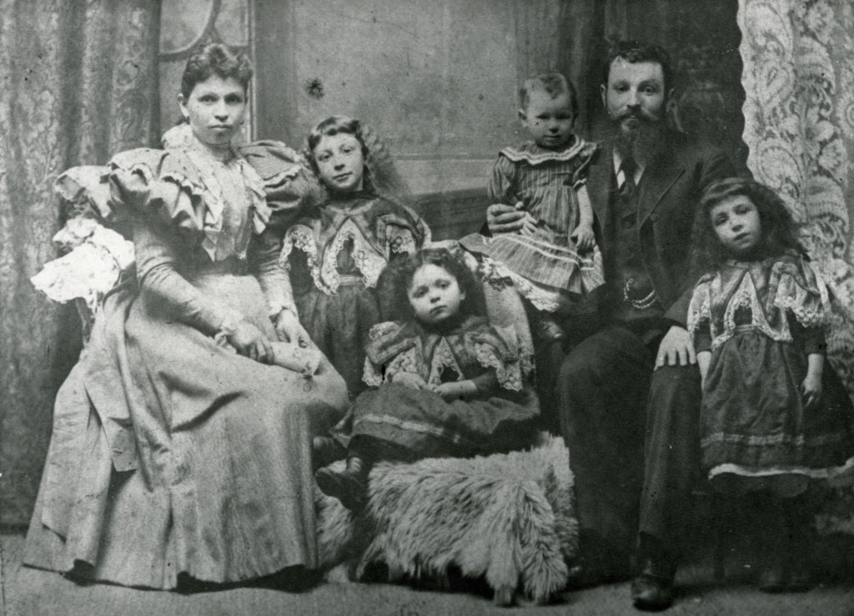
Rottenberg Family, Toronto, 1897. (Image courtesy Ontario Jewish Archives, Blankenstein Family Heritage Center)
During the first two decades of the 20th century, Canada’s total Jewish population increased from 16,401 in 1901 to 125,197 in 1921, which represented 1.42 percent of the country’s total population. Much of this increase owed to the arrival of thousands of Russian and Eastern European immigrants, who were not especially welcomed with open arms.
Whether they lived in Montreal with a Jewish population of 45,803 in 1921, Ottawa with 3,041, Saskatoon, Saskatchewan, with 599, or Brandon, Manitoba, (130 miles west of Winnipeg) with 222, Jews were all generically classified as “Hebrews” by the non-Jewish world, which did not appreciate or even understand the religious and ideological distinctions within the larger Jewish community, or its ancient disputes. Canada was and remained primarily white, Anglo-Saxon, and Protestant. In 1912 and 1913 the country received 776,626 immigrants, of which 39 percent were British. And by 1921, English, Scottish, and Irish (many Roman Catholic) Canadians accounted for approximately 53 percent of the country’s total population. Add in the French, Germans, and Scandinavians, and Canada was overwhelmingly Northern European. Nevertheless, Jews, Italians, Ukrainians, and other Eastern Europeans attracted a lot of attention—and little of it positive.
The ever-increasing number of Jews in Toronto, for example, was disturbing for the white Protestant majority. In 1921, the city’s Jewish population was 34,770, which was only 6.6 percent of the total; yet it was 30,000 more than there had been two decades earlier. They were a highly visible group, segregated as they were in the Spadina–Kensington Market area.
The Toronto Globe’s editors raised an alarm about “a Jewish invasion of the public schools.” And the Toronto Telegram expressed grave concerns about the opening of the new and impressive Beth Jacob synagogue on Henry Street in 1922. Two years later, the same issue was addressed even more virulently by the Telegram. “An influx of Jews puts a worm next the kernel of every fair city where they get a hold,” an editorial stated. “These people have no national tradition. … They are not the material out of which to shape a people holding a national spirit. … Not on the frontiers among the pioneers of the plough and axe are they found, but in the cities where their low standards of life cheapen all about them.”
In the minds of politicians, public health officials, church leaders, teachers, journalists, and members of the business community, the Jewish, Southern and Eastern European, and Asian newcomers were members of objectionable “races,” who dressed in peculiar garb, ate food with garlic and other Byzantine spices, and spoke strange languages. It was the conventional wisdom of the day that these immigrants contributed to the growing poverty and congestion in downtrodden urban neighbourhoods where drunkenness, crime, and prostitution flourished.
There was some truth to these charges. Around St. Lawrence Boulevard in Montreal, the Ward in (downtown) Toronto, and the North End of Winnipeg, many Jewish immigrants indeed lived in abject poverty in slum housing (often rented from Jewish landlords) where disease was rampant.
In 1906, a group of ladies from the Winnipeg Ministerial Association visited a North End Jewish home and reported on the appalling living conditions they discovered. “Forty-five families inhabited a very small space, living in a manner that was to say the least disgraceful,” the ladies wrote. “Diseases of all kinds were common. … It was just the spot for a plague to begin and sweep over the city, and it was providence that such had not occurred.” In Montreal in 1908, Jewish cemeteries did not have room for the large number of Jewish paupers who required free burial.

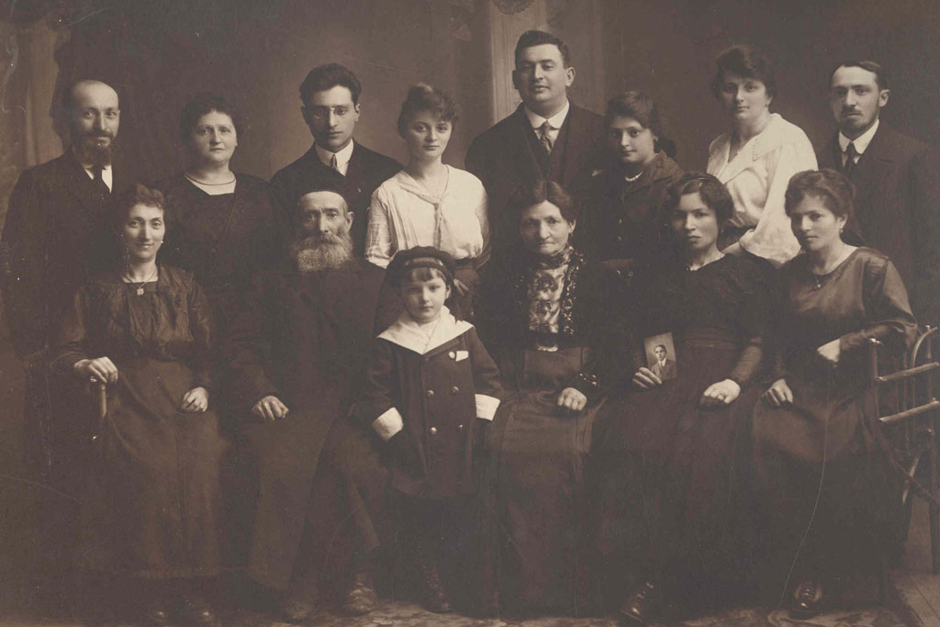
Mr. Henry Dworkin and immigrants, between 1920 and 1928. (Image courtesy Ontario Jewish Archives, Blankenstein Family Heritage Center)

There may not have been many Jewish brothel owners or pimps, but small-scale bootlegging was definitely popular among Jewish immigrants as a way to make a few dollars.
The long list of Jewish bootleggers included Getel (Gertrude) Shumacher (the grandmother of Toronto civic politician Howard Moscoe) who followed in the footsteps of her brother Shmuel, who was also a bootlegger, and sold shots of whiskey out of the self-styled “grocery store” located in her house in Toronto’s Ward neighborhood to supplement the family income; the parents and grandmother of Toronto Jewish boxing champion Sammy Luftspring, who offered their clientele 25-cent glasses of rye; and Abraham Bellow in Montreal.
By 1923, Abraham, then 42—and the father of 8-year-old Saul, destined to become one of the great American writers of the 20th century—was up to his neck in debt. He had already failed as a baker, dry goods salesman, junk dealer, marriage broker, and insurance agent, among other pursuits. Bootlegging was a last resort and a poor choice: He and his partner were beaten and robbed while driving to the Quebec-New York border with a truckload of whiskey.
Across the country, Jewish communities—large, medium, and small—quickly learned that no one was responsible for the welfare of their members except the communities themselves. The success of these various endeavors owed mainly to the philanthropic efforts of selfless individuals, among them two remarkable women, Ida (Lewis) Siegel and Lillian (Bilsky) Freiman, both born in 1885.
Siegel was from Pittsburgh, but as a young girl came to Toronto with her mother to reunite with her father, who had found work in the city. She was (like her older brother Samuel Lewis) a committed Zionist, and in 1906, at the age of 21, she was instrumental in organizing a group to assist young Jewish immigrant women and mothers—only the first in a long list of her volunteer achievements. She actively promoted education for girls, sports for Jewish children, and was one of the founders of Hadassah, the most notable Zionist women’s group in Canada.
Lillian Freiman and her husband, Archie, were also committed Zionists. Thirty years old when the First World War broke out in 1914, Lillian spearheaded numerous charitable activities. She supported the Red Cross, raised money for orphanages and refugee efforts—in Ottawa, she was later known as the “Poppy Lady” for her pioneering work promoting the poppy campaign for veterans—and became president of the Dominion Hadassah women’s organization. Siegel and Freiman set the standard for others to follow. And, as a response to the many needs of the Eastern European immigrants, ladies’ Hebrew benevolent societies were organized in nearly every Canadian Jewish community across the country.
Still, there were grumblings about Jewish self-segregation and the impact of the newcomers from established Jews such as Montreal lawyer Maxwell Goldstein, who in 1917 became the first president of the Federation of Jewish Philanthropies, which evolved into the Combined Jewish Appeal. In a 1909 interview with London’s Jewish Chronicle, he bemoaned that the cause of many of the community’s problems was “the vast influx of foreign Jews into the Dominion [of Canada].”

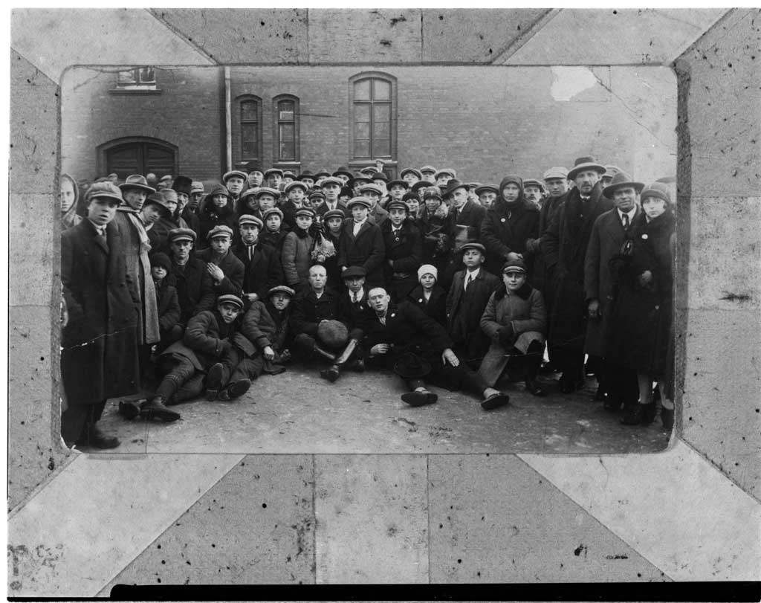
Group of Jewish immigrants from the ship Regina at Halifax, 1927. (Image courtesy Ontario Jewish Archives, Blankenstein Family Heritage Center)

These immigrants, he added, “form ghettos among themselves and create a great deal of prejudice.” The great irony of this classic Catch-22 situation would have been lost on Goldstein. Jews could not win, no matter what they did. If they remained poor and ghettoized, they were disdained as a cancer on Canadian society. On the other hand—at least until the 1960s—the more acculturated Jews became, the more they were resented by the Christian majority for being too pushy and for threatening the status quo.
Compassion and understanding for this deplorable situation only went so far among large segments of the WASP majority. There was, in fact, a backlash against undesirable minorities, the result of a deep-seated xenophobia that was to remain a part of un-multicultural Canadian society at least until the 1960s.
Expressing a widely shared view, Frederick Barlow Cumberland, a British-born Ontario writer and sportsman, declared to the members of Toronto’s Empire Club in 1904 that “we are the trustees for the British race. … We hold this land in allegiance.”
French-Canadian nationalists were of the same mind: In 1911, while addressing an Anglo-Canadian meeting, journalist Olivar Asselin complained about the “exotic babbling” Jews in Montreal, who in his view had degraded the city’s character. (Asselin later reconsidered his attitude toward Jews, and condemned French-Canadian anti-Semitism.)
In an age when the eugenics movement, with its theories about the alleged link between biology and morality, was popular, Canada—or so it seemed— was under siege from unwanted “foreigners” and “aliens” who could never assimilate to “Canadian” values and standards. In future Labour politician Reverend J.S. Woodsworth’s book Strangers Within Our Gates, published in 1909, the saintly and compassionate Social Gospel advocate—who in the face of the severe urban problems of the early 20th century preached an activist Christian charity to improve the lives of the poor and destitute—and politician outlined his belief (shared by many others) that British, Scandinavian, German, and French immigrants would make much better Canadians than “Hebrews,” Slavs, and “Orientals” (Chinese, Japanese, and Hindus). The prospects for “Negroes” and “Indians” (Indigenous Canadians) were even more dismal.
Public school teachers ultimately tasked with “Canadianizing” the immigrant children were likewise skeptical. Teachers encouraged their foreign students to learn English by any means possible—and, more significantly, imparted to their young charges the “correct” moral values. This meant teaching them respect for law and order and having them embrace “thrift, punctuality, and hygiene.”
As one Toronto public school teacher put it, Canadians are “tidy, neat and sincere—foreigners are not.” The conservative Winnipeg Telegram summed up such fears even more concisely. “Better by far to keep our land for children, and children’s children of Canadians,” its editors argued in mid-May 1901, “than to fill up the country with the scum of Europe.” Such anti-immigrant sentiments would persist in Canada for the next several decades.
Excerpted from Seeking the Fabled City: The Canadian Jewish Experience. Allan Levine, © 2018. Published by McClelland & Stewart, a division of Penguin Random House of Canada Limited. Reprinted with permission of the publisher. All rights reserved.

Reprinted from the November 2, 2018 email of Tablet Magazine.
We’re All Jews Here
By Rachel Ginsberg

Over 70 years later, the almost-untold story of Master Sergeant Roddie Edmonds has unleashed a worldwide movement toward heroic living

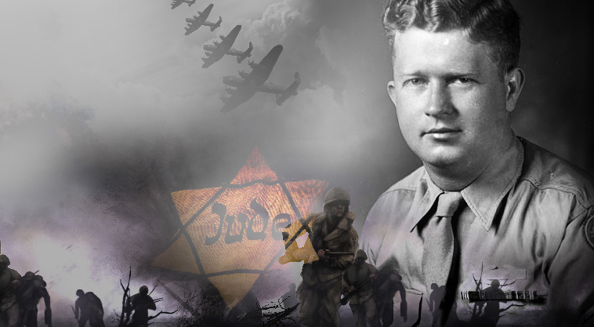
(Photos: Family Archives)

Some people struggle their entire lives wondering about their purpose in this world. Others can change the face of humanity in a matter of minutes — and no one might ever know. That’s what’s so amazing about the nearly untold story of Roddie Edmonds, an American soldier captured by the Germans toward the end of World War II, who in a split second made a decision that would save hundreds of Jews and foster inspiration for a new generation.
In a remarkable World War II story that was nearly buried together with Edmonds, this devoutly Christian US army sergeant from Tennessee refused to turn over hundreds of his Jewish soldiers even as a gun was placed to his head. He was finally recognized for his bravery more than three decades after his passing in 1985, when the story of those few fateful life-and-death minutes was discovered and publicized by his son, Pastor Chris Edmonds — and has fueled a worldwide chain reaction toward acts of kindness and morally elevated choices. This Veterans’ Day, Pastor Edmonds has a lot to be proud of.
Roderick W. (“Roddie”) Edmonds was a master sergeant with the 422nd Infantry Regiment, which was shipped out to Europe in the fall of 1944. In December the troops were sent to the Ardennes forest on the Belgian-German border, where the German army launched a surprise, ruthless offensive that became known as the Battle of the Bulge.
Though outmanned, the Americans managed to hold off the Germans long enough to allow General George Patton’s troops to finally come to the rescue, but that rescue came too late for the 422nd and 423rd regiments. Those who weren’t killed in the onslaught were taken to the POW camp Stalag IX-B, where they were practically starved to death: Once a day they were fed some rancid broth with a tiny piece of black bread made with sawdust.
As bad as it was for the POWs across the board, the Jewish American captives had it the worst. The Wehrmacht treated captured Jewish soldiers the same way they treated all Jews — they either murdered them or dispatched them to brutal slave labor camps, such as Berga, where the odds of survival were slim. Because of this policy, the US military warned its Jewish soldiers that, if captured, they should destroy any evidence of their religion, such as dog tags that were stamped with an “H” (for “Hebrew”), identifying documents, siddurim, or other ritual objects some soldiers carried.
After a month in Stalag IX-B, Roddie — the highest-ranking noncommissioned officer among close to 1,300 fellow American POWs — was transferred with the rest of the Americans to the larger Stalag IX-A camp near Ziegenhain, Germany, which held thousands of Allied soldiers of various nationalities. The POWs, having been starved for weeks, were marched through the deep snow with cracked, blistered feet, wearing the same lice-infested clothes in which they had been captured a month before.
Inside the gate, the soldiers were met by a pack of growling German attack dogs. The camp commandant then brought a young Russian POW forward. “You are free to go,” the commandant told him encouragingly. The Russian didn’t believe him — he knew it had to be a trick, but the Germans had actually opened the camp gates for him. After standing there puzzled for several minutes, the prisoner ran toward what he thought was his freedom. Suddenly the Germans let the dogs loose. The young Russian was ripped to shreds, as the newcomer American POWs were forced to watch. Anyone who closed his eyes or looked away was rifle-butted in the head.

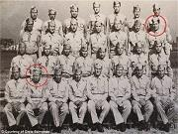
Master Sergeant Roddy Edmonds (front row) was together with new recruit Lester Tanner (in back) in Camp Atterbury in 1943, where they were being trained for overseas combat. When they’d meet up again as POWs, it would be life-altering

“Remember this!” the commandant shouted. “This will be your fate if you don’t do exactly as we say!”
The next night, with the grisly vision of the murdered Russian fresh in the minds of the Americans, there was an announcement over the loudspeaker — only the Jewish POWs were to fall out the following morning to be counted, and any Jewish soldier who did not appear would be shot on the spot.
There were about 200 Jewish soldiers in the group and each one of them knew what that “selection” meant. So did Master Sergeant Edmonds — he’d seen the Jewish soldiers separated back in Stalag IX-B when they were first captured. That night, he told the entire group of Americans under his charge, “We are not doing that. Tomorrow we all fall out.’ ”
The morning of January 27, the Americans stood together outside their barracks — all 1,292 of them. Commandant Siegmann saw that all the Americans had fallen out and was furious with Edmonds. “I am ordering you to tell only the Jewish men to line up! These men cannot all be Jews!”
Edmonds looked Commandant Siegmann straight in the eye and said, “We are all Jews here.”
Enraged, Commandant Siegmann took out his Luger and pressed the barrel to Edmonds’ forehead, right between the eyes and fingered the trigger. “You are under orders to separate all the Jews right now!” he shouted. “You will order the Jews to step out or I’ll shoot you on the spot!”
Edmonds, a staunch Methodist who had little or no contact with Jews growing up in Knoxville, calmly responded, “Sir, according to the Geneva Convention, we are only required to give our name, rank, and serial number. If you shoot me, you will have to shoot all of us because we’re all witnesses, and when we win this war, you will be tried for war crimes.”
The commander was livid, but Edmonds stood his ground. Finally, Siegmann put the gun back in its holster and stormed away. And 200 Jewish lives were saved.

Too Sick to March
Returning to civilian life, Roddie Edmonds never mentioned the incident. But then again, nor did he ever talk about how he saved the entire American group of POWs soon afterward, once the Allied forces were closing in. With the Allies on their heels, the Germans ordered the whole camp to evacuate — thousands of soldiers were to be marched out, but Edmonds knew the march through snow-covered terrain would mean the end for his starved, emaciated soldiers. The POWs could hear the fighting in the distance, someone had a radio and heard BBC reports, and they realized the Allies were close by — and Edmonds knew their only chance of survival was to wait it out until the Allies arrived.
“We’re not going,” he told his troops. “I need all you men to get sick tonight — eat dirt, grass, vermin, anything to make you sick. Tomorrow when we fall out, we go back to our barracks and tell the Germans we’re too sick to move.”
The next day, that’s exactly what happened. The German guards screamed, barked, and threatened, but in the end, they let the Americans stay by themselves as everyone else was marched out of the camp. Nearly all the POWs forced out died on the march — yet every one of the Americans who stayed put made it back home alive, after being liberated by General Patton’s troops.
After the war, Roddie Edmonds returned to Knoxville, was again shipped overseas to fight in the Korean War, and then upon his permanent return, married and eventually settled into a career in sales related to mobile homes and cable television. He passed away in 1985 as a humble, church-going man of faith, loving father, and die-hard patriot, yet never having received any official recognition, citation, or medal for his defense of the Jewish POWs. His heroism would have been buried with him, if not for some providential detective work by his son, Pastor Chris Edmonds of Maryville, Tennessee.
“We Were Humiliated” More than 20 years after Roddie Edmonds passed away, Chris Edmonds’ daughter Lauren told her father she had to do a project on a family story for her college history class. She knew her grandfather was a POW in World War II, but not a lot more than that — no one in the family knew much more than that.

Chris Edmonds with Prime Minister Netanyahu at last year’s Jerusalem Leadership Summit. “I thanked him on behalf of Israel for honoring Dad,” says Edmonds. “Dad’s story is about all the principles we hold dear”

“I thought it was a great idea,” Pastor Edmonds tells Mishpacha, describing the events that led to a surprising revelation, new cherished relationships, and finally, Yad Vashem’s “Righteous Among the Nations” award, Israel’s highest honor for non-Jews who risked their lives to save Jews during the Holocaust — the first such award for an American soldier, and the first such award for rescuing American Jews.
“We knew that Dad had served as a master sergeant in the army, and my mom still had the diaries he’d kept as a POW in Germany,” Pastor Edmonds says. “I was just as excited as Lauren was to go through the diaries, so we read them together. But what we found was that many things seemed to be encrypted. Dad’s descriptions were brief and to the point — just a few sentences about how they were captured and the conditions in the POW camp. He also listed the names and addresses of the men in his barracks. But many of the horrible events seemed to be written in a kind of shorthand. In fact, from the time I was a kid and asked Dad about the war, he’d just say, ‘Chris, we were humiliated. Things that are too bad to share.’ So I stopped asking.”
Lauren wrapped up her project, but for Pastor Edmonds, it was just the beginning. He wanted to know what really happened during the war, and what all the vague, shorthand references in the diary were really about. In time, he would learn the truth.
“I Googled Dad’s name and rank,” Pastor Edmonds says, “and the first result that popped up was a New York Times article about a lawyer named Lester Tanner, who had sold his Manhattan townhouse to former US president Richard Nixon after he’d resigned and left the White House back in 1973. No one wanted the disgraced president to live in their building, but when Tanner heard about Nixon’s predicament, although he was a lifelong Democrat and didn’t share Nixon’s political views, he was appalled by the blackballing and sold Nixon the property.
“In the course of that interview, Tanner told the Times reporter that he’d served in the military in World War II, was a POW in Ziegenhain, and that the German commandant would have had him and all the other Jewish POWs killed if not for their brave officer, Master Sergeant Roddie Edmonds. Wow, I thought. Dad must have done something huge — but what?”
Pastor Edmonds flipped back to January 1945 in the diaries, but all he found that might be an explanation was a mysterious entry: “Before the commander.” What was that referring to? The heroism Tanner had mentioned? Edmonds actually found Lester Tanner’s name in his father’s handwritten list of his men, and searched online for a current address.
“This was in 2012. I discovered that he was a prominent attorney in New York, still practicing at age 89. I e-mailed him and asked if I could visit him. Lester replied that same afternoon. ‘I would love to meet with you,’ he wrote. ‘I owe everything to your father.’ ”
Pastor Edmonds traveled to New York and met the man his father had saved 67 years before. Lester Tanner, who has subsequently become a dear friend (“he’s 95 today and still incredibly active”), told Pastor Edmonds that he’d originally met his father in 1943, when Lester was a new recruit and Roddie Edmonds was his sergeant. They were both captured in the Battle of the Bulge and met up again in Stalag IX-A. That fateful day in January 1945, Tanner was standing right next to Edmonds when the commandant put the gun to his head.
“From the moment your father told the commandant, ‘We are all Jews here,’ I decided that for the rest of my life, I would always do the right thing, even if it was dangerous,” Lester told Chris Edmonds. “Not a day goes by that I don’t thank G-d for him.”

Never a Bad Day
Pastor Edmonds’s reunion with Lester Tanner was not only the key to revealing his father’s heroism, it also brought him in touch with three other veterans his father had saved who were still living. “Lester lost track of Dad and never saw him again, but he kept in touch with some of the others, and we became like instant family in the last few years,” says Edmonds.
One of those men was Sidney “Skip” Friedman from Cleveland, who passed away in 2015. “Skip told me, ‘Chris, we were as good as dead in that camp. And the day we were liberated, we were reborn. Since then, I’ve never, ever, had a bad day.’
“You know, when Skip told me that, I finally figured out something about the way Dad lived,” Edmonds continues. “When he came into a room, he lit it up, and when he left, you wished he were still around. He was so encouraging, so supportive, never critical. He loved everyone, from little kids to elderly seniors, and now I understand it — back in the war, these men didn’t expect to survive, and the fact that they did gave them a new lease on life. Because of the crucible Dad had been through, every new day for him was a gift.”
Another Jewish veteran who became part of this old-new family was Paul Stern, who passed away last year. When Stern, who served as a combat medic, was captured in the Battle of the Bulge, his group was forced to march for four days straight in subzero temperatures, surviving on snow as there was no food or water. At the POW camp Bad Orb Stalag, he was first segregated together with the other young Jewish prisoners in an inner camp, where they were given lice-infested mattresses made from putrid straw and where six men shared a slice of bread and a small bowl of soup made from rotten potatoes and other scraps.
Stern, however, was removed from the Jewish group and had the good fortune to be sent to Ziegenhain with the other noncommissioned officers — avoiding the fate of the other Jewish privates who were shipped off to work in Berga, the underground slave-labor munitions factory in East Germany where many didn’t survive. That’s because just weeks before his capture, he saved the lives of three enlisted men and an officer on the battlefield, earning the promotion to corporal.
“While Lester was on Dad’s left when the commandant put the gun to his head, Paul was on his right, so he was able to corroborate the exact details of what happened,” says Edmonds. Tanner and Stern became good friends in that prison camp, and after the war, even became brothers-in-law. Lester told him back in Ziegenhain, “Paul, if we ever get out of here, you gotta come to my house in the Bronx and have some of my mom’s Jewish cooking.” Paul took him up on the offer, came over for dinner, and met Lester’s sister Corrine — they were married soon after.

Roddy Edmonds was the first US soldier to be recognized as “Righteous Among the Nations” by Yad Vashem. In the ceremony at the Israeli Embassy, his old friends came to pay tribute. (Standing, from left) Sonny Fox, Lester Tanner, and Ambassador Ron Dermer; in the wheelchair is Paul Stern a”h
The other living veteran saved by Roddy Edmonds is Irwin “Sonny” Fox — the youngest of Chris Edmonds’ four new friends, who’s a sprightly 93 today. In the 1960s, Sonny Fox was a television host of the popular children’s program Wonderama, served as a game-show host during the ’60s and ’70s, and has been a longtime broadcasting consultant. Tanner had lost touch with him after the war, but the two reconnected in 2000 when Fox came back to New York to write his memoirs.
Once Chris Edmonds connected with Tanner, Fox, Friedman, and Stern, this well-heeled group felt Roddy Edmonds was deserving of the national Medal of Honor, and after learning of the story, many congressional leaders have since been behind the move for the prestigious U.S. government honor. The initial U.S. Army position, however, has been that since Roddy Edmonds was a captive and his actions were not in combat, he would not be eligible for the award. And so, congressmen from the elder Edmonds’ home state of Tennessee have introduced a bill to have Edmonds honored with the Congressional Gold Medal instead, and are waiting for it to pass the congressional committees.
Meanwhile, Yad Vashem recognized Edmonds as a “Righteous Among the Nations” exactly 71 years after his heroic action — in a ceremony held on January 27, 2016, at the Israeli embassy in Washington — in the company of Tanner, Stern, Fox, and then-president Barack Obama.
They Were All Heroes Pastor Edmonds believes that life circumstances as well as faith-based instruction helped carve out his father’s strong moral core.
“Thomas Edmonds, my grandpa, was a strong man of faith,” he says. “Grandma died when Dad was just three — she had a goiter and there was nothing they could do for the massive swelling in her neck.
Grandpa never remarried, but moved in with his sister instead, and she was the one who raised Dad. Dad, remember, was born in 1919, and was part of the generation that grew up in the hardships of the Depression. They knew how to appreciate everything in life without talking about it.”
The irony that no one knew of his dad’s heroism until he’d been gone 30 years isn’t lost on Chris Edmonds. Today, though, he’s making sure the world knows about it, although the one niggling question people always ask is: How come Roddy never told anyone?
“Well, there was certainly the factor of Dad’s characteristic humility,” the younger Edmonds explains, “but I think it was also about the nature of that generation. Today you digitally report to everyone what you ate for breakfast, but back then, those who served in the war tended not to talk about it until many years later — not until their grandchildren started peppering them with questions.
“People ask me, were they reticent because of the trauma, because they felt they were just doing their duty, or because of an innate sense of honor and humility? What I can tell you,” Pastor Edmonds continues, “is that what they experienced was traumatic and life-altering. I believe Dad specifically didn’t elaborate in his writing and left things encrypted because many of the events were too painful to talk about, although he left in enough details to realize they went through horrible times.

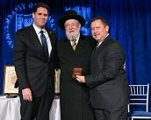

At the Israeli Embassy, Ron Dermer and Rabbi Yisrael Meir Lau join Pastor Edmonds in celebrating Roddy’s life.

For example, one page is just dash marks with the words ‘Jewish friends moved out’ — that happened in the first camp. He was referring to how they separated the Jews and sent them to an inner prison behind more barbed wire before they were transferred to Berga where many of them were killed or worked to death.”
Another example was the one-word entry: “Dogs.” That was a reference to the horrifying scene of the Russian being torn apart by the attack dogs.
“And it was quite amazing,” says Edmonds, “that right after watching that gruesome scene, all the Americans agreed to defy orders and fall out together with their Jewish comrades. True, Dad led the way, but he wasn’t the only hero. They were all heroes.”
But there was another piece in the diary that could shed light on the reticence of these men. “In the back of his diary,” says Edmonds, “Dad talks about his attending some kind of security briefing after their release, where the men were to make a commitment not to talk about what happened while they were overseas. At the time, the army felt any information could compromise US security and it was important to maintain a policy of secrecy. Remember, the war wasn’t over yet and the army was planning on sending those soldiers back overseas.
“Lester told me, ‘All us POWs were scared to death we’d have to go back and fight the Japanese. We were thrilled when Truman dropped the bomb, because being captured by the Japs meant you were as good as dead. When it came to warfare techniques and torture, they were the worst.’ ”

Extraordinary Choices
Pastor Edmonds has spent the last three years promoting what he calls “Roddie’s Code,” a sort of contagious movement to create awareness that it’s possible to make moral choices in everyday life, that people can choose to live differently.
“Even in those moments of danger between life and death, Dad made the lightning-quick decision to stand up for his men and confront evil,” says Edmonds. “But when people hear Dad’s story, they’re thinking he must have been a cross between John Wayne and Clint Eastwood, but Dad was an ordinary man who made extraordinary choices in extraordinary times.”
Pastor Edmonds believes that the “Roddie’s Code” initiative has succeeded in taking that inborn moral energy and pushing it forward into this weak, self-centered generation. “It crosses over all religions and faith models,” he says. “Everyone gets it. There’s a hunger out there for heroic living and real heroes — real people who do the right thing. Young people say to me, ‘Your dad really did that?’ It’s so foreign to them! So I tell them, you can be the same way, you can do it for others — it just means standing on your convictions and doing what’s right.
“Look, I know I’m just one person and can’t change the world on my own, but I believe people are receptive to this message: that whenever you’re confronted with the need to step up and do the right thing, think about Dad, and choose to defend life and decency. Tell yourself, ‘I can treat people better.
“I can make good choices.’ Choose to esteem others over yourself — and not just when a gun is pointed at your head. It means letting someone go ahead of you in line, opening the door for someone to go in first, taking responsibility for others. I’m praying for a movement, for people across the planet to decide to live heroic in all their choices.”

Reprinted from the Parshat Vayeitzei email of AJOP (the Association of Jewish Outreach Projects.) Originally printed in the November 7, 2018 Issue 734 of Mishpacha Magazine.
A Pop-up Shul Rises
In the South Bronx
By Dan Whateley

Chabad struggles for a foothold in a fast-changing area that once was teeming with Jews.

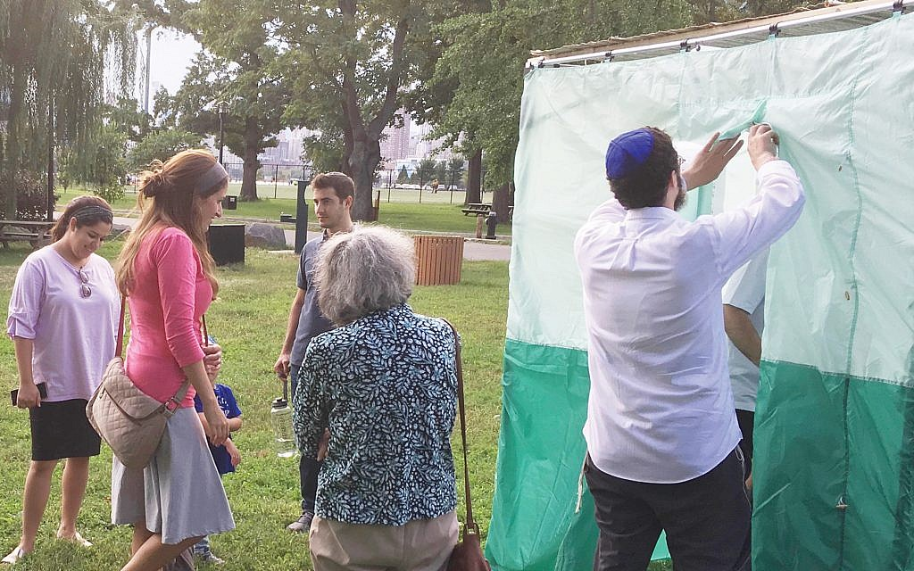
Rabbi Choli Mishulovin, invites people into a sukkah on Randall’s Island. Courtesy of Dan Whateley

It’s been more than a decade since the last Orthodox synagogue in the South Bronx closed its doors. “It was a beautiful shul,” resident Rita Friedman said of the shuttered Congregation Hope of Israel in the Concourse neighborhood. “Stained glass windows, carpeting. A balcony up on top.”
Now, riedman attends services at an upstart synagogue, Chabad South Bronx. It’s the first Orthodox congregation in the neighborhood in 12 years. Unlike its predecessor, Chabad South Bronx has no permanent building, running services in donated retail and residential spaces in the borough.

Rabbi Mishulovin, left, at a “Sukkah Fest” event last month along the East River. Photos by Dan Whateley

The synagogue’s rabbi, Choli Mishulovin, held this year’s Rosh HaShanah service in a vacant delicatessen on 161st Street just off the Grand Concourse and a four-minute walk from Yankee Stadium. As Rabbi Mishulovin blew a shofar near the deli’s entrance, he drew the attention of passersby who peered through the glass to identify the source of the sound. After the service, the rabbi and his wife, Chana Mushka, invited locals into the 800-square-foot deli for plates of extra apple cake and stuffed cabbage.
The Rosh HaShanah ceremony occurred on the same block as the historic Concourse Plaza Hotel, a venue once known for bar mitzvahs and Jewish weddings that now functions as public housing for seniors. The hotel is one of several buildings in the South Bronx that have been repurposed to serve the changing needs of the neighborhood following a decline in its Jewish population after the middle of the 20th century.
In the 1930s, more than 360,000 Jews lived in the South Bronx, according to “The Lost Civilization of the Jewish South Bronx” by Seymour J. Perlin. Thousands of Jews left the borough in the second half of the century, but the number of Jewish households in the Bronx actually increased by 25 percent — from 24,200 to 30,200 — between 2002 to 2011, according to UJA-Federation of New York.
“In terms of the Jewish community, this area is really changing,” service attendee Michael Trencher said after the Rosh HaShanah service. “People are coming up here because it’s affordable. Great housing stock and ease of commute.”
Jennifer Rosenberg, director of research at UJA-Federation, can’t say for sure what’s driving growth in the borough’s Jewish population. “There’s all kinds of things that you can wonder about,” she said. “We do have some detailed data on the Riverdale and Kingsbridge areas in the Bronx. For the rest of the Bronx, there were just too few interviews to say anything statistically viable.”
Overall, the population of the South Bronx has grown in recent years as revitalization efforts continue, with census data showing an 11.5 percent increase in the Highbridge neighborhood from 2000 to 2010. The real estate website Zumper listed Highbridge as the New York City neighborhood with the highest rent increases in 2017.
To accommodate a growing population and improve access to affordable housing, the City Council voted in March to rezone a 92-block section of the Bronx along Jerome Avenue. While implementation has just begun, the rezoning has the potential to add thousands of new housing units to the neighborhood in the coming years. Real estate developer Maddd Equities has plans to build roughly 750 new units at two locations in the rezoning area near the Grand Concourse, according to The Real Deal.
Rabbi Mishulovin himself is a Bronx newcomer, having lived in Crown Heights, Brooklyn, the site of Chabad-Lubavitich’s world headquarters. He led his first service in the Concourse neighborhood a little over a year ago in the basement of an apartment building. Michelle Daniels, a resident of the neighborhood, invited the rabbi to host the service after gauging interest among locals. “I thought it was about time we brought the Jewish community back to the South Bronx,” Daniels told The Jewish Week in a phone interview.
Trencher, a friend of Daniels , said, “Michelle was looking, trying to establish some type of organized Jewish practice in this area. The timing was right.”

A view of the Concourse Plaza Hotel, at right, on the Grand Concourse. Chabad South Bronx’s held a Rosh HaShanah ceremony at a deli on the same block as the hotel. Photo by Daniel Whateley.

Rabbi Mishulovin moved to the South Bronx with his wife and their two young children in April. For now, one of the main tasks for the couple is finding congregants in a borough that has just recently seen an increase in its Jewish population.
Only two visitors showed up to a September shofar and holiday snack event held in the basement recreational room of the Mishulovin’s building. The pair, Jerry Schein and Sam Yampolsky, sipped pomegranate cocktails and tasted honeycomb and star fruit as the rabbi’s toddler wandered through the room, accidentally spilling a handful of honey sticks across the floor.
Attendance at the rabbi’s events this year has varied from just a few worshippers to more than a dozen. Congregant Rita Friedman says she can count the number of local Jews she knows on her fingers. “There’s pockets of Jews around. There’s about eight or 10 I know of.”

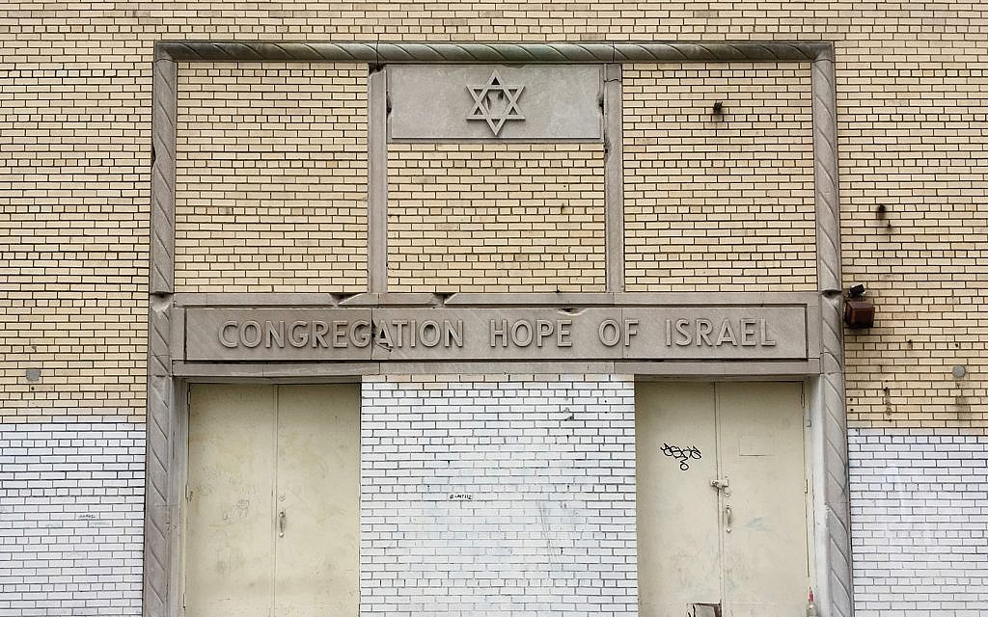
The long-shuttered Congregation Hope of Israel in the South Bronx. Courtesy of Dan Whateley

Friedman grew up in the South Bronx and watched as its Jewish population declined. “We had some older Jewish neighbors in our building,” she said. “A few moved to Brighton Beach, and the rest died out.” Friedman herself moved away from the borough for a period, returning five and a half years ago to live with her mother, Barbara Friedman, who also attends Chabad South Bronx events.
Rabbi Mishulovin and his wife are promoting events in the neighborhood using Instagram, email and word-of-mouth. The rabbi says he has spent time walking through the neighborhood to meet community members. “We want people to be a little more involved in their Judaism,” he said.
The couple’s approach is common in the Chabad-Lubavitch movement. When young rabbi emissaries and their families move to a new community to establish a Chabad House, they often use their own home to recruit, host services and run events.
Jerry Schein learned about Chabad South Bronx after meeting the rabbi at a local grocery store. He grew up in the South Bronx and, like Friedman, attended services at the now-shuttered Congregation Hope of Israel. He says he feels welcomed into the new community, attending most of Chabad South Bronx’s events. “The fact that they’re bringing out Jewishness and celebrating the holidays, that’s very meaningful to me.”
Standing next to a pop-up sukkah during a recent “Sukkah Fest” on Randall’s Island, Rabbi Mishulovin said he is still figuring out how to organize a congregation that has no permanent location.
“We want people to be a little more involved in their Judaism,” he said. “A lot of people have problems with organized religion. One of the advantages with us is we’re not organized,” he said, laughing.
Rabbi Mishulovin says he would take permanent space right away if it became available. “This,” he said, “is what we have to work with now.”

Reprinted from the October 24, 2018 website of the New York Jewish Week.

The Unstoppable
Yehudit Abrams
By Rabbi Shraga Simmons

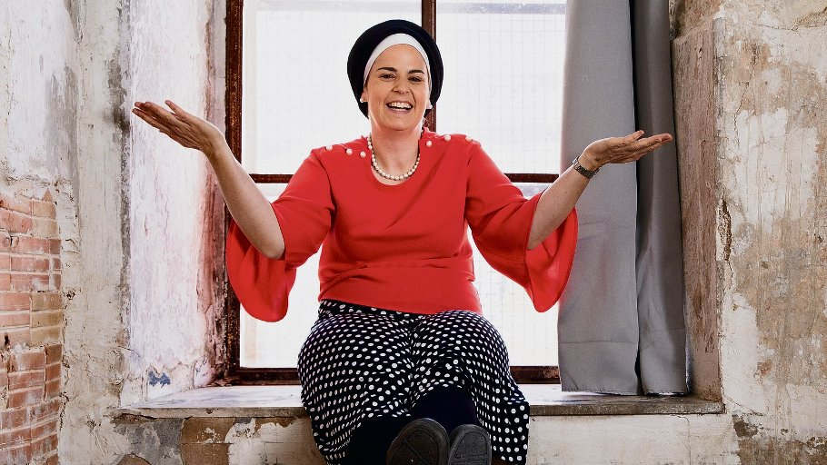
The hi-tech maverick who recently won $360,000 for her early detection breast cancer device is also a convert to Judaism. This is her amazing story.

Standing before a crowd of 5,000 at the We Work Creator Awards this summer in Jerusalem, Yehudit Abrams had reason to be nervous. This moment represented the culmination of many dramatic twists and turns: childhood in a devout Quaker home; Orthodox Jewish conversion; researching ultrasound to support the Mars mission at NASA; mingling with tech elite in Silicon Valley; and conducting medical relief missions around the world.
Standing there under the spotlights, with WeWork's legendary founder Adam Neumann looking on, Yehudit took a deep breath and focused on how breast cancer claims another life every 74 seconds.
Yehudit said a prayer and launched into the pitch for MonitHer, the first at-home, hand-held monitor for early detection of breast cancer. With a combination of engineering and medical expertise, fierce entrepreneurial spirit, and unstoppable energy and passion, Yehudit described her vision to revolutionize one of modern medicine's most perplexing challenges.
Minutes later, Yehudit was awarded first prize of $360,000.

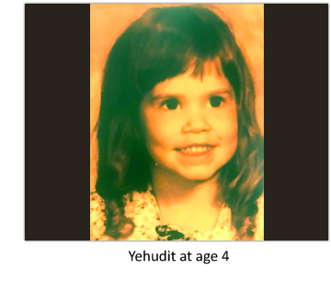
Born Holley Abrams in Boise, Idaho, the road to here has been complex, dramatic, and deeply inspiring.
"I grew up in a family of cowboys and ranchers, raised as a devout Quaker," Yehudit tells Aish.com near her office in downtown Jerusalem. "My mom is very spiritual, and talking to G-d is something instilled in me from an early age. If an ambulance drives by, we'd say, 'Please G-d, take care of this person and let them not suffer'."
A precocious and razor-sharp child, Yehudit was encouraged to explore the worlds of music, science and adventure. Yet when it came to religion, she was taught "not to question."

I was Born Questioning.
"The problem is, I was born questioning," Yehudit says. "As a Christian, it didn't make sense to me that man could be G-d. It also didn't make sense that because someone died, I'd go to heaven. Nor did it make sense that G-d is divided into three entities, since by definition a First Cause can't have a split beginning."
By age 10, Yehudit began studying other religions like Daoism and Buddhism. She eventually settled on Transcendental Meditation – connecting with a local instructor and meditating diligently throughout junior high and high school.
From a young age, Yehudit was self-reliant. Her parents divorced, leaving a father uninvolved, a mother working two jobs, and a brother off with his friends. "I cooked for myself and grew up fast," she says.

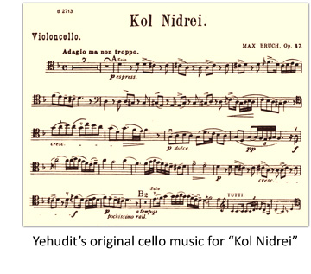
As age 13, Yehudit randomly raised her hand when the school music instructor asked if anyone wanted to play cello. That night she took the instrument home and an unbreakable lifelong bond was formed. She excelled at cello, going on to win statewide solo completions.
Her cello teacher gave her the sheet music for "Kol Nidrei," the solemn prayer that begins Yom Kippur services. "Even before I played it, I sensed something special," Yehudit says. "I stared at the music and it was like the notes were popping off the page. When I played it, every hair on my body stood up straight. I couldn't explain it and I needed to find out its origins."
Yehudit opened the Boise yellow pages and called the local synagogue for the schedule of services. That Friday evening, she dropped in at Boise's legendary synagogue built in 1865, the oldest synagogue building in continuous use west of the Mississippi. Though a tiny congregation with no rabbi, Yehudit was welcomed by a middle-aged lay leader named George, a convert to Judaism and the son of a KKK Wizard in West Virginia. George agreed to answer all of Yehudit's questions and gave her the book, Judaism & Christianity: The Differences.
"I fell in love with the services, the community, and the study" she says. "It felt like home."
Yehudit continued meditating and pursuing a Jewish education. At age 15, she wondered if any Kohanim, descendents of the Jewish priests, lived in Idaho. She flipped open the phone book and found one "Cohen." Reuben Cohen, who happened to live directly across the street.
"It was late in the evening and I went outside, laid down and looked up at the stars," Yehudit says. "I thought about the blessing given to Abraham, and asked G-d to send someone to teach me more about Judaism."
At that moment, a short, stocky, 78-year-old man emerged to throw out the garbage. "I ran across the street and asked him, 'Are you a kohen?' Reuben stiffened with pride and said, 'Yes, I am a kohen. What else would you like to know?'"

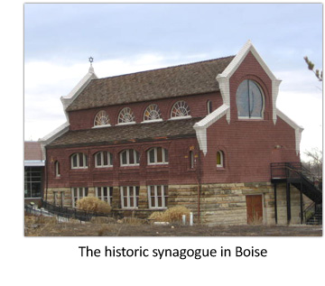
The two stood outside talking till 3 a.m. It was a match made in heaven. Reuben's wife passed away 10 years earlier, leaving him all alone. "He became my best friend and my surrogate father," Yehudit says. "Every day after school, I'd go straight to his house. He was a walking encyclopedia. Every night we'd talk history and politics, and he'd cook me dinner."
Though Reuben had not been to synagogue for 50 years, Yehudit's enthusiasm caught on and they began attending services regularly together.
Conversion and Medical School
In high school, Yehudit decided to become a Jew. Wanting to experience Judaism in the "optimal way, in Israel," she noticed a flyer at the synagogue for Sar-el, the program to volunteer at an army base or hospital. In 1993, one week after high school graduation, 80-year-old Reuben and 17-year-old Yehudit set off together to Israel.
After six weeks, Reuben went home to Idaho and Yehudit stayed, lodging at the Heritage House while looking for a conversion program. "I cried on every rabbi's desk and they politely turned me away," she says. "That was G-d's way of saying: 'How badly do you want to become a Jew?'"
That year, on Yom Kippur, Yehudit attended services overlooking the Western Wall. She had since discovered she was born on Yom Kippur, and memories came rushing back of the "Kol Nidrei" sheet music that started this whole journey.
"That day I surrendered everything to G-d. I asked, with every fiber of my soul: 'I will do your will for the rest of my life. Just help me become a Jew.'"
Life as a Jew felt brighter and more potent. That special feeling has never gone away.

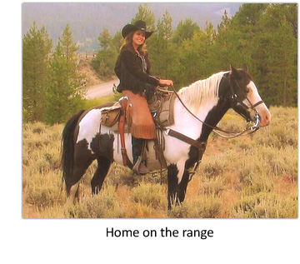
The next day, Rabbi Asher Wade, himself a former Christian pastor, gave Yehudit the phone number of Sharei Bina, a women's seminary in Tzfat. The director, Tova Weingot, warmly accepted Yehudit and pledged to shepherd her through the conversion process. "I studied morning till night, drinking in Torah," she says with an enormous smile.
One year later, Yehudit completed her conversion under Rabbi Avraham Auerbach of Tiberias. "I emerged from the mikveh into a different reality," she says. "Life as a Jew felt brighter and more potent. That special feeling has never gone away."
With one big goal checked off, Yehudit's next priority was pursuing her dream of eventually becoming a doctor. After 6 months of ulpan, her Hebrew was still not at university level, so she moved back to the U.S. and studied mechanical engineering at Oregon State. "There were virtually no women in engineering back then," she says, relishing the role of a maverick. "The entire department had one small women's bathroom – a converted janitor's closet. I saw this as an opportunity to break some norms."
Yehudit solidified her engineering bona fides with internships at HP and Intel, then chose to attend medical school at Charles University in Prague, the oldest university in Central Europe, founded 1348. Every summer during medical school, she joined different medical teams – in Guyana, the Czech Republic, the Appalachian Smoky Mountains, rural Idaho, and at Tel Hashomer in Israel.

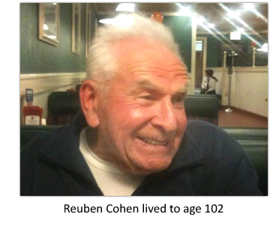
Her conclusion from these experiences was disheartening. "Treatments were mostly superficial, prescribing a pill but not diagnosing the problem due to the lack of diagnostics," she says. "That's when I began thinking of how to apply engineering to medicine, to create point-of-care diagnostics."
In the NASA "Sandbox"
On a whim during her senior year of medical school, Yehudit applied to Singularity University, an elite technology think tank and business incubator. The 10-week program, held on the NASA campus in California, exposes creative leaders to cutting-edge, exponential technologies, with the goal of creating companies whose target is to impact a billion lives.
Yehudit was accepted to Singularity and awarded a $25,000 scholarship from Google. "It was an incredible summer," she says. "We learned the business side of start-ups, which sparked my entrepreneurial streak. After hanging out with Elon Musk, Larry Page, astronauts and Nobel laureates, my take-away was that we all have greatness within. I can do big things, too. That was an empowering realization."
After hanging out with Elon Musk, Larry Page, astronauts and Nobel laureates, my take-away was that we all have greatness within.
At Singularity, Yehudit became friendly with NASA's chief medical officer. She was hired and "thrown into the sandbox," the building where young engineers collaborate on innovative NASA projects.
Yehudit was put on a NASA team working on medical devices to support astronaut health during space missions. "Because Mars is such a long-duration mission," she says, "you need to identify, diagnose, and treat with the same device. That's the beauty of working at NASA – they set impossible standards and expect you to achieve huge things."
In 2010, following the devastating earthquake in Haiti that killed a quarter-million people, Yehudit went to assist the medical relief teams. She surveyed hospitals and saw patients day and night. Seeing that one of Haiti's main hospitals, servicing 400,000 people, had only one X-ray machine, she began thinking of how to make ultrasound affordable, portable, and easy to use."
Yehudit returned to NASA where she helped develop a futuristic wearable "ultrasound patch," she calls a "body window" that sticks to the body and performs continuous imaging and medical diagnosis – all with low-energy requirements and no physical side effects.
With Yehudit's background in mechanical engineering and medicine, hi-tech connections, and out-of-the-box thinking, the pieces were falling into place for a creative breakthrough in portable ultrasound.
Meanwhile, she still had unfinished business with her medical career and turned her focus to getting a residency. Little did she know of the detour life would take. She had met her husband at NASA, had a baby boy, and soon after divorced. Suddenly, Yehudit was a single mom and her medical career stalled. "I spent the next five years applying for different medical residencies, and every time something else interfered with my plans. I was frustrated at the delay in my plans."
It would, of course, prove a blessing in disguise.
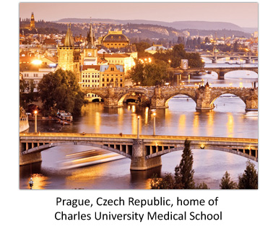

Puzzle Pieces
During her time at NASA, Yehudit's cousin – a breast cancer survivor who had discovered the disease through self-exam – was killed in a car accident. That's when Yehudit decided to focus her attention on the early-detection of breast cancer. Being at home with her son, she had time to digest all she had learned over the years, and to begin drafting ideas for monitoring breast health.
Breast cancer can metastasize rapidly, making it critical to detect it at an early stage. "Once the cancer metastasizes, the five-year survival rate can drop from 95% to 23%," she says. Of the 250,000 cases of invasive breast cancer diagnosed each year, she says only 60,000 are stage 0 cancers that can be easily cured. "Breast cancer can metastasize in a few months, yet we're screening every one-to-two years. The numbers prove that mammography alone is not detecting it early enough."
Yehudit blames the problem on the limitations of current screening methods. Mammography, she explains, delivers a high rate of false-positives – as many as one in three. "Mammography is not finding aggressive breast cancers early enough, cannot alone reliably image dense breasts, or be used to monitor high-risk women, and cannot differentiate some cancers that may not need treatment from those that do. This causes over-diagnosis and unnecessary biopsies. In the U.S. alone, 20,000 women proactively remove their healthy breasts to avoid living with anxiety and fear. We want to eliminate such unnecessary intervention."
Fortuitously, Yehudit was hired by an ultrasound start up for the next 4.5 years, where she honed her knowledge of ultrasound, skills as a scientist and investigator, and formed scientific relationships that would later be critical to her own start-up. She also learned from the company’s mistakes after they went bankrupt due to poor management.
By this time, Reuben, her surrogate father, had died at age 102. Yehudit's son was of school age, and she felt it was time to move to Israel.
Yehudit wanted to find breast cancer in its earliest state, keeping survival rates above 95%.
In the meantime, Yehudit wrote out her own ideas for a completely novel approach to screening for breast cancer. Instead of screening for cancer, she wanted to monitor health, in order to find breast cancer in its earliest state keeping survival rates above 95%.
She filed a patent for the MonitHer breast health monitoring system in which monthly whole breast ultrasounds are performed in the home in order to detect any breast changes. In the event of any suspicious change, the user sends historical images of the area of the breast in question via secure link to a physician for review. This removes the guessing game for physicians whether or not to perform a biopsy. MonitHer utilizes an FDA-approved software developed by one of her collaborators.

Grand Prize
With a bright future in the Holy Land, and after five years at home raising her son, Yehudit saw the move as a perfect opportunity to get her medical career back on track and complete her training in radiology. She applied to a residency lottery in Israel, not knowing which hospital she would get. "My first choice was Shaare Zedek in Jerusalem. It's run according to Jewish law and was my dream hospital from when I was a teenager living in Israel," she says.
Yehudit began 2018 with Aliyah, along with her son and mother, settling in Jerusalem's urban hip neighborhood of Nachla'ot. Incredibly, she was accepted at Shaare Zedek, slated to start her residency in July 2018. In the meantime, she applied to MassChallenge, a prestigious startup accelerator focusing on high-impact, early-stage entrepreneurs. The Israeli branch received over 500 applications from 40 countries, and Yehudit was selected to participate. "This gave me access to advisors, classes, and a space to work out of," she says.

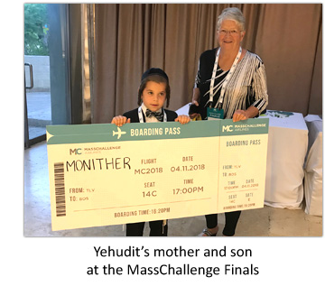

In April 2018, after seeing a notice for the WeWork Awards, Yehudit quickly submitted a "pitch video." Based on the criteria of social impact, ability to scale, and commercial potential, MonitHer was accepted to compete.
The competition pitted MonitHer against endeavors as diverse as organic farming and solar-powered water desalination.

"Moments before going onstage, it all came together. The years of engineering, the inability to return to residency which led to many years of ultrasound research. Nothing had gone my way. But that was not my deal with Hashem. I gave my life to do His will, and now perhaps this was Hashem’s will for me.”
Yehudit says. "I looked out at the crowd and realized that of those thousands of people, one in eight women would be diagnosed with breast cancer in their lifetime. I knew what I had to do and wasn't nervous anymore. I understood that it's not about me. And I made a commitment: Whatever G-d wants from me, I'll do. Just show me the way."
The grand finale of the night was the announcement of WeWork's $360,000 first prize. (Adam Neumann the Shabbat-observant Israeli founder of WeWork, is partial to prize money in multiples of 18, Chai.)
As "MonitHer" was announced the winner and as confetti rained down, Yehudit was momentarily stunned. "I sensed my entire life coming together," she says pensively. "G-d and Torah is the undercurrent of my entire path, how I got to this point today. Those five years of frustration at not getting a residency was G-d's way of enabling me to stay home and spend lots of quality time with my son."

Beyond this, Yehudit found those years at home allowed her entrepreneurial side to flourish. "Caring for an infant is a wonderful time for creativity," she says. "I had the luxury of developing my ideas, conducting ultrasound research, and making connections with scientists around the world who now support the work I'm doing. Raising a child is a time to be creative, to explore oneself and let G-d guide you in a direction."
How does Yehudit handle being an anomaly, an Orthodox woman in hi-tech, particularly while wearing a traditional Jewish head-covering?
"Observant women approach me all the time, saying that I am an inspiration. Just as I thrived as a mechanical engineer in a department comprised almost entirely of men, so too, I carry with pride the crown I wear on my head. Covering my hair is an obvious statement to me, that I have my priorities where they belong. I think it conveys the message that I’m a proud Jew, serving G-d through the technical background He granted me."

Into the Future
After the awards ceremony, Yehudit didn't stick around basking in accolades. She headed straight to the airport for a pre-planned visit of Jewish historical centers in eastern Europe. It was in Uman, at the grave of Rebbe Nachman of Breslov, that she confronted an enormous quandary:
"My end-goal all these years was to finish my residency. I was scheduled to start residency at my dream hospital the following week. Yet with MonitHer looking so promising, I needed to decide: Should I throw myself 100% into running the company, or should I bring in someone else?"
In Uman, Yehudit got her answer. "I meditated and listened for a still, clear voice. The voice said: 'Go and don't look back.' I had been focused on my medical career, but G-d had other ideas."
Yehudit flew back to Israel and told the folks at Shaare Zedek she would have to cancel. They were upset, but understanding of her decision.
The WeWork prize money has been earmarked to build a hardware prototype of the actual home breast monitoring device. Experience shows that any medical hardware product requires lots of money and manpower – years of research, plus rigorous clinical studies to obtain FDA approval. Projections are that the product will be available to consumers in three to four years.
In order to focus more on the engineering and medical aspects of development, Yehudit is on the verge of announcing a co-founder, what she describes as "a powerhouse businesswoman who was CEO of a highly successful medical device company."
MonitHer is just getting started, and it appears as if Yehudit is hurtling toward her destiny. In July, MassChallenge Israel selected MonitHer as a top startup of 2018, earning a spot at their prestigious innovation symposium in November. And she is currently competing to get to the WeWork Global Finals at Madison Square Garden in January 2019.
The challenging times are G-d's way of leading us to something greater.
After years of adventures, including 8 universities on 3 continents, Yehudit is back where she belongs, thankful for the long and winding road. "When you raise yourself alone at age 8, it's obviously very challenging, but it forces you to take charge of who you want to become," she says. "The challenging times are G-d's way of leading us to something greater."
"We are democratizing early detection by bringing clinical grade diagnostics into the home, enabling the earliest most accurate detection of breast cancer possible.
"This is not about me," Yehudit says with fire in her eyes. "This is saving lives – pikuach nefesh. Every minute, another life can be saved."

Reprinted from the August 21, 2018 website of Aish.com

A Train Ride Back
To the Old Israel
By Matti Friedman

It takes four times as long as the
new high-speed rail. I take it anyway.

The Jerusalem-Tel Aviv rail line has run off and on since 1892. Photo Credit - Corinna Kern for The New York Times

JERUSALEM — Last month, the first section of a new high-speed rail line opened in Israel. When it’s fully operational a few months from now, passengers will board fire-engine-red carriages in Tel Aviv and be whisked on electrified track over the country’s longest bridge, then over its highest, and through the longest tunnel, and finally into a new station 260 feet under Jerusalem. The trip, about 35 miles, will take less than 30 minutes, making it, by a wide margin, the fastest way to get between the country’s two most important cities.
The line, more than a decade and many delays in the making, is the new Israel. Or at least what Israel would like to be: a place that can look any Western country in the eye. The Israeli train of 2018 is shiny, fast and travels in a straight line.
But progress has its victims. And here it’s the old country — a small, inefficient but compelling place that Israelis call the “good old land of Israel.”
The old Israel is represented in this case by the main casualty of the new train: the historic Jerusalem-Tel Aviv line, which has been running on and off since 1892 and isn’t likely to run much longer.

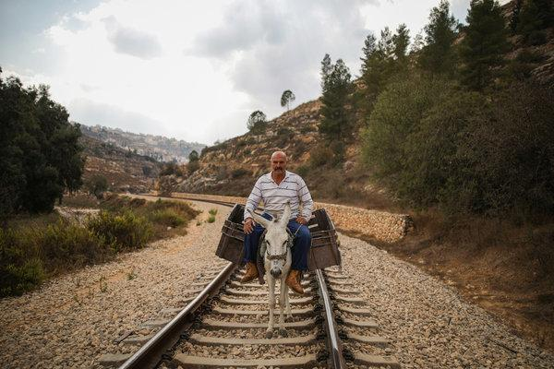
A donkey ride along the railway route between Jerusalem and Tel Aviv. Photo CreditCorinna - Kern for The New York Times

Like the old Israel, the old train is sporadically functional. It can take four times as long as the new service and twice as long as driving. It’s so impractical for most commuters that even before the appearance of its flashy rival, it was nearly empty much of the time. But the old train has a modest cult following, of which I’m a proud member, and I’d hate to see it pass from the world without proper tribute.
I’m writing these lines in the first carriage of the 10:57 a.m. from Jerusalem, winding down through the Sorek River Valley at the speed of a bicycle. In the winter months the landscape is as lush as Ireland, but now, at the end of a long summer, it’s dry olive-green and limestone under a pale blue sky.
We pass near the homes of the Palestinian village Bittir, where an old man looks out from a stone terrace. Eucalyptus trees lean overhead, and at some of the sharper turns it feels like we might tip into the stream beside the track. After about 20 minutes without a sign of human habitation, the valley bottoms out, the train cuts through a rock quarry and a few miles of citrus orchards, and makes a few listless stops before the 21st century abruptly reappears in the form of skyscrapers, billboards and the energetic urban tumult of Tel Aviv.

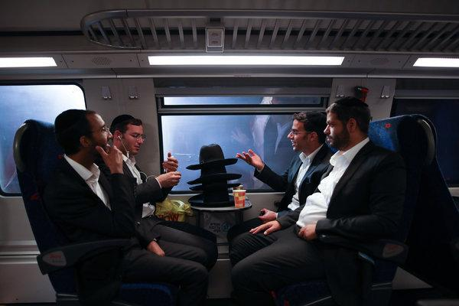
Passengers on the new railway line from Jerusalem to Tel Aviv Ben Gurion Airport.CreditCorinna Kern for The New York Times

“I ride the old train because it lets me see landscapes that haven’t changed in thousands of years,” Deborah Harris, a Jerusalem literary agent and another of the train’s aficionados, told me. “It feels like traveling through space and time.” The train is a commute, a nature excursion and time travel, all for $5.60.
An early account of the train was written by Theodor Herzl, the founder of modern Zionism, who rode it in 1898 from the port of Jaffa, adjacent to modern-day Tel Aviv. At the time, the train was the only one in this remote and impoverished corner of the Ottoman Empire. Herzl, a Vienna journalist who’d come part of the way east on the luxurious Orient Express, thought it was awful. “It took an hour merely to leave the Jaffa station,” he wrote. “Sitting in the cramped, crowded, burning-hot compartment was pure torture.” One day, Herzl thought, there would be a modern Jewish state here, and a wonderful network of electric rails. (The new train is, 120 years later, Israel’s first electric line.)

The new Yitzhak Navon railway station in Jerusalem, 260 feet underground. Photo Credit - Corinna Kern for The New York Times

The train’s birth, six years before Herzl boarded, was the doing of a Jewish businessman from the old Sephardic community of Jerusalem, Joseph Effendi Navon, with the help of Swiss and French investors and the blessing of the sultan in Istanbul. The company laid just one track to save money, according to a history of the line by Anthony Travis of Hebrew University, and made it of narrow gauge to navigate the hills.
Jerusalem’s residents were Jews, Muslims and Christians who tended to be pious and poor. Many had never seen a train. When the first one arrived on Aug. 27, 1892, an elderly Jewish woman at the station declared the smoking, clanking behemoth to be “possessed of the devil,” a reporter noted, and a frightened group of Muslim kids nearby agreed.

A tourist from China takes in the view on the slow train from Tel Aviv to Jerusalem. Photo Credit - Corinna Kern for The New York Times

One history describes the line’s construction as “catchpenny and defective,” but others were enthusiastic. “Like a dreamer I watched the high mountains, the hills, the valleys and the plains of grass that passed by me, engrossed in thoughts about the making of such a superior machine,” an early passenger from Jerusalem wrote in one of the Hebrew newspapers. Of historical interest to early passengers was Bittir on its hillside by the tracks, thought to be the site of ancient Beitar, where a Jewish revolt against Rome led by Shimon Bar Kokhba ended in defeat in 135 C.E.
Hebrew was being revived just then as a language for daily use, and new words were required for things absent in the Bible, like trains. A teacher in Jerusalem suggested the word “katar” for locomotive, from the word for “steam,” and a Zionist leader came up with “rakevet” for railroad. Both words are in common use today.
Problems on the line began immediately — foul-ups, flooding, near-bankruptcy and even sabotage by the Bittir villagers, some of whom seem to have been camel drivers or porters who feared that modernity was about to put them out of business, as indeed it was.

Trains on the old historic route get there when they get there. Photo Credit - Corinna Kern for The New York Times

7But the train steamed on, threading through this country’s remarkable century. It survived World War I, when sappers blew up bridges to slow the British advance against the Turks, then ran through the three decades of the British Mandate. Two British guard posts from the 1930s still stand by the track. After the war around Israel’s creation in 1948, the route became the cease-fire line between Israel and Jordan, the train running just inside Israeli territory. In 1967 the land on the other side of the track, the West Bank, including Bittir, came under Israeli control.
The train traveled through years of political turbulence, by the Jewish trees and the Arab trees and the trees that don’t belong to anyone. In the manner of the old Israel, it seemed aware of the landscape, skirting hills instead of tunneling through them.
There were faster and easier ways to travel, and you were welcome to take those; the train wasn’t for everyone. It arrived when it arrived.
The old train’s fate hasn’t been settled. There’s a chance it could be maintained as a “tourist line,” a railway spokesman told me, which would probably mean a few trains on weekends and holidays. It won’t make sense to run empty trains, and there seems little chance that regular service will continue.
The new train will be able to move more than 3,000 people an hour each way, quickly and efficiently. Few of them will know what they’re missing.
Matti Friedman (@MattiFriedman), a journalist, is the author of the memoir “Pumpkinflowers: A Soldier’s Story of a Forgotten War.”

Reprinted from the October 17, 2018 website of the New York Times.

The Reburial of
The Chida, Zt”l

One of Rabbi Mordechai Eliyahu's early predecessors as Rishon L'Zion, Sephardic Chief Rabbi of Israel, was Rabbi Yitzchak Nissim, who had a special appreciation and admiration for the CHIDA (Rabbi Chaim Yosef David Azulai). One of Rabbi Nissim's friends was Dr. Shlomo Umberto Nachon, a native of Livorno (Leghorn), where the Chida lived the end of his life and was buried. In the late 1950s, Dr. Nachon learned that the Italian authorities wished to build a highway through the Jewish cemetery of Livorno.
He quickly informed Chief Rabbi Nissim and, understanding the urgency of the situation, they decided it was time to move the Chida to Eretz Yisrael. Dr. Nachon made the arrangements with the authorities in Livorno, and in 1960 Rav Nissim commissioned, after much coaxing, the then 31-year-old Rabbi Mordechai Eliyahu, who was known to be intimately familiar with the Chida's writings, to head a team of esteemed Sephardic rabbis (which included Rabbi Yisrael Abuhatzeira, the Baba Sali, and his brother the Baba Haki, Rabbi Yitzchak Abuhatzeira, chief rabbi in the city of Ramle, who was an expert in Jewish burials in his native Morocco) for the reinterring of the bones of the Chida in Jerusalem. Rabbi Eliyahu related that when he arrived at Lod Airport with the other rabbis, he met with the agency representative who had brought the bones of the Chida in a small wooden coffin. When the Rav saw it, he was appalled "What is this?" he asked. "The bones of the Chida are rolling around in a miniature coffin? How can such a thing be?"
He asked that a larger coffin be brought, so that the bones could transferred to it and be laid out properly for an honorable burial. Then he requested that the Baba Haki's driver go with his driver, and that they immerse in a mikva [ritual bath], and afterwards buy a Phillips screwdriver to open the coffin. When they returned, Rabbi Mordechai Eliyahu made a large hole in the bottom of the new large coffin so that there would be no barrier between the bones and the soil upon burial, but temporarily closed the hole with a stopper.
Then the small coffin was inserted into the larger one. Rabbi Eliyahu had the small coffin opened, whereupon he put his hand in to arrange the bones. But after a few moments he trembled and closed his eyes. Saying in a broken voice that he had no power to do it , he asked pleadingly that the Chida himself put his own bones in order!
Immediately a powerful, almost explosive sound was heard, the coffin began to shake, and a rattling sound -- made by the Chida 's remains striking the coffin's walls -- was heard. All the other rabbis fainted on the spot. Rav Mordechai did not faint, explaining afterwards that his absorption in the mitzva helped him remain conscious.
It was beyond belief! The banging and shaking continued until, bone by bone,the entire skeleton was arranged perfectly -- in the merit of the holy rabbi, the Chida! "G-d will grant you special Providence, and bring my remains out of this place." [Bereishis. 50:25]
"He said to me, 'Can these bones live?'…As I prophesied, there was a roaring sound, and the bones came together and joined one another…. 'I am going to open your graves; I will take you out of your graves, My People, and bring you to the Land of Israel.'" [Ezek. 37:3, 7, 12]
Thousands accompanied the funeral procession from the Jerusalem neighborhood of Sanhedria to the cemetery at Har HaMenuchos. At the burial, Rav Eliyahu described the events that had taken place as "Nisei nissim--absolute miracles."
At a later date Rabbi Mordechai Eliyahu announced that whoever needs personal salvation can go to pray at the grave of the Chida It is no wonder that when Rabbi Mordechai Eliyahu passed on to his heavenly great reward fifty years later that he was buried near the Chida on Har HaMenuchos! [Adapted by Yerachmiel Tilles ascentofsafed.com]

Reprinted from the Parashat Bereishit 5779 email of the Young Israel of Midwood’s (Brooklyn) whY I Matter parshasheet.
The Nazi Downstairs: A Jewish Woman’s Tale of Hiding in Her Home
By Colin Moynihan
A search for a lost masterpiece uncovered a woman’s harrowing account of escaping deportation, and possibly death, while spying a Nazi at close range.

Elsa Koditschek was living in a prosperous section of Vienna, near the foothills of the Alps, when the Nazis, who had annexed Austria, confiscated her home in 1940. A German officer, a squad leader in the SS, soon moved in.
Mrs. Koditschek, a Jew, was allowed to stay on, in an upstairs apartment, a tenant in her own house for about a year, until a deportation edict arrived ordering her to a bleak, uncertain future in a Polish ghetto. She fled instead, leaving behind her life’s possessions including the only major artwork she had ever purchased, a landscape by Egon Schiele.
For years, she hid in the homes of non-Jewish friends, according to an account she gave in dozens of letters written during and after the war. But she was ultimately desperate enough to seek refuge in the house the Nazis had seized from her, sneaking back in to live there in secrecy and silence with an upstairs tenant.
From there, she spied on the SS officer, Herbert Gerbing, watching through a window as he sat in the garden with his family. Probably unbeknown to her, while she hid upstairs, he was helping with the deportation of Jews across Europe.
“Who would think I would find myself sharing a roof with an SS officer?” she wrote later in a letter to her son, Paul, who had moved to New York years earlier.
Mrs. Koditschek’s Schiele was ultimately sold during the war, while she struggled to survive, and it has been sold several times since.
But her letters, handwritten on onionskin and intact after having been carefully packed away in a relative’s basement, helped the Koditschek family and researchers at Sotheby’s piece together the provenance of the painting. So this fall in New York, when it goes up for auction with an estimated value of $12 million to $18 million, Mrs. Koditschek’s heirs will share in the proceeds with its current owners.
“It’s so unusual to have a victim of Nazi theft or expropriation who writes everything down,” Lucian Simmons, the worldwide head of restitution at Sotheby’s, said. “Usually you’re trying to join the dots, but the dots are far apart.”

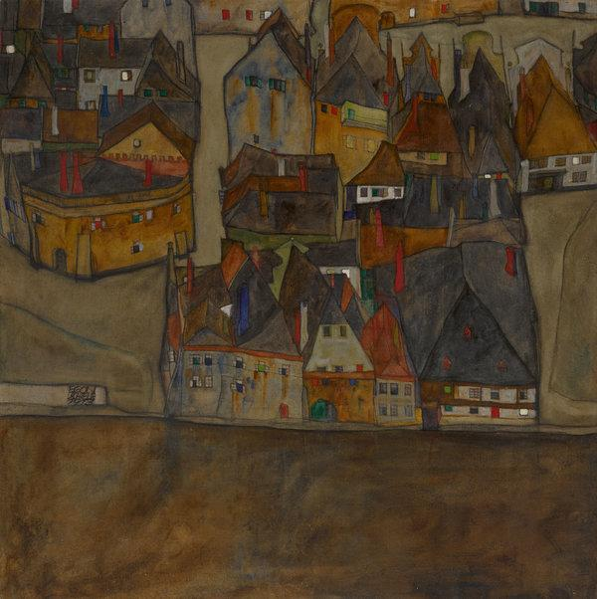
Egon Schiele’s “City in Twilight (The Small City II),” painted in 1913, was owned by Mrs. Koditschek. Photo Credit via Sotheby's

Mentions of the Schiele painting in the letters buttressed the provenance research by Mr. Simmons, who had approached the family in 2014 after independently finding indications that it had lost an important painting during the war. What followed were several years of negotiation with the current owners of the Schiele, Europeans who had bought it in the 1950s, that led to an agreement that will govern the sale next month of the work, “City in Twilight (The Small City II)” painted in 1913.
“It’s an important painting with a wonderful revolutionary abstract form,” Mr. Simmons said.

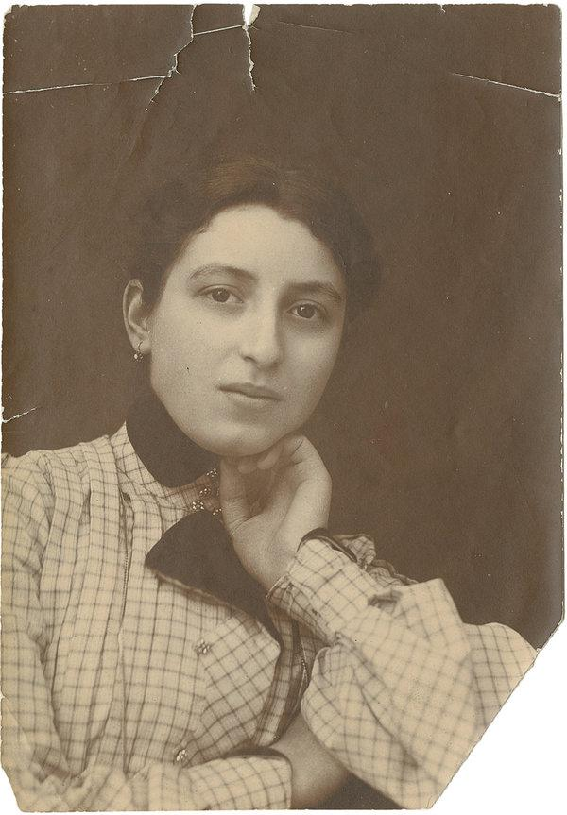
A picture of Mrs. Koditschek, taken in the 1920s.Credit via Sotheby's

Perhaps more remarkable than the painting is the tale that accompanies it: the account of woman made vagabond by the Nazis who ended up returning to the very house from which she had been evicted, and living out the war there, just feet above one of her persecutors.
Mrs. Koditschek survived the war, and related her account in many letters to her son, who died in 1974. But he seldom discussed those experiences in any detail, so relatives have only recently begun to unravel Mrs. Koditschek’s history by sifting through the correspondence. (Sotheby’s provided translations of excerpts from the letters.)
Their tone deepens as events evolve, according to Sarah Whites-Koditschek, a great-granddaughter, and turns grim in 1941 when the deportation order arrives. At that point, Ms. Whites-Koditschek said, “She’s just writing about whether she can find any way to escape.”
Steven Luckert, a historian with the United States Holocaust Memorial Museum in Washington, said that Mrs. Koditschek’s experience stood out even among the startling tales of Jews who had lived through the war hiding in Nazi-occupied cities. “The fact that she was living in the same house as someone who was in charge of deportations makes it even more extraordinary,” he said.

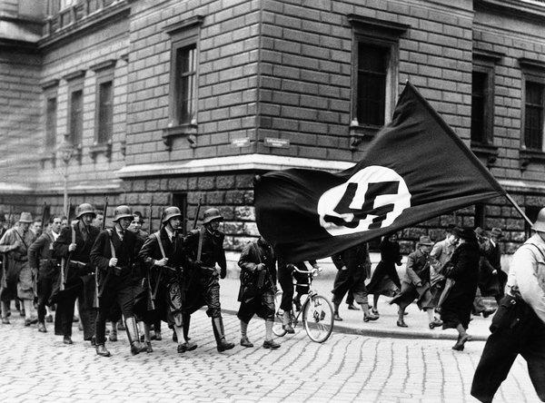
Armed Nazi youths march through the streets of Vienna in March 1938 after Hitler’s annexation of Austria. Photo Credit - Associated Press

Mrs. Koditschek, the widow of a banker, had sent her son and daughter away to safety before Europe became engulfed in war. But she stayed behind in Vienna, living in the three-story home her husband had built in 1911. She lived on the first floor, below her longtime tenant, Sylvia Kosminski, who was known as “Aunt Sylvia” though she was not a relative.
When the Nazi and his family took over the first floor, Mrs. Koditschek moved to the second to share quarters with Aunt Sylvia, bringing with her, the Koditschek family believes, the Schiele painting.
The letters do not indicate that Mrs. Koditschek was particularly fearful of the Nazi she was living with. He occasionally summoned her to explain how things in the house worked. She described his demeanor as civil, even after she received “an ominous card” directing her to show up at a school to be deported to German-occupied Poland. When she asked the officer if the trip could be delayed, he replied that it could not, she wrote. But he painted a glowing portrait of what life would be like in the Lodz ghetto and offered a word of advice, suggesting she bring a minimum of belongings.
“This was a kind thing for him to say,” Mrs. Koditschek wrote, “because the luggage of most Jews was robbed even before they arrived at their destination. Also of course their lives.”
It does not seem, based on her letters, that Mrs. Koditschek had an inkling of Mr. Gerbing’s larger role in the deportation of Jews. Yad Vashem, Israel’s Holocaust remembrance center, describes him as a key player in executing those policies and said he “participated in raids and arrests, and was reported to have been exceedingly brutal, at one case causing grievous injuries to detainees.”
When Mrs. Koditschek fled, she lived with a family named Heinz and spent virtually all of her time indoors, often hiding for hours behind a cupboard inside their apartment. She passed the lonely hours by practicing her English or playing chess against herself.
But her life there was disrupted in 1943, Mrs. Koditschek wrote, when Mr. Heinz came home one day “under the escort of some strange men” who began searching the apartment. She slipped away though an open door.
“I must have been wearing a magic cap of invisibility because the plainclothes men did not notice me,” she wrote, adding that as she roamed the streets that night, “people stared at me as if I was a ghost from another time.”
Under cover of darkness Mrs. Koditschek met Aunt Sylvia, and they returned to her home, rushing inside, she said in a letter, “when the coast was all clear.” For the next two years she lived a clandestine life there, sleeping on a makeshift bed and hiding whenever the doorbell rang.
Mr. Gerbing was not often home, she wrote. Historians have recorded that he had a role in deportation efforts in Paris, Slovakia and Thessaloniki. When he was away, Mrs. Koditschek noticed, Jewish laborers, marked by badges, would carry the plunder of war — furniture, a piano, clothing — into her home. “Wherever he stays,” Mrs. Koditschek wrote, “in Greece, in France, in Slovakia, he sends big boxes back with goods from each country.”
“If there was something that had to be repaired in the house,” she wrote, “the Jews came again, and they also labored in the garden.”

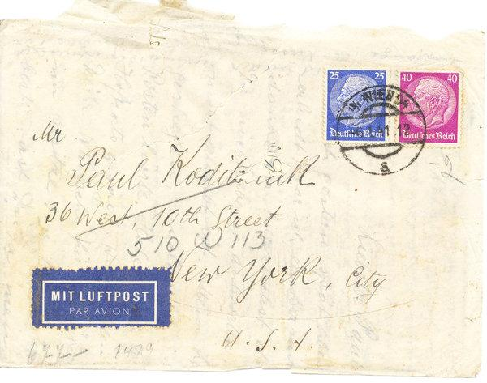
A letter Mrs. Koditschek wrote to her son, Paul. Her preserved, translated letters proved invaluable in tracking the provenance of the Schiele painting .Photo Credit via Sotheby's.

As compelling as the letters are, they leave much unanswered. How did Mrs. Koditschek completely avoid notice? Was Aunt Sylvia Jewish, and if so, how did she escape persecution?
Still, Ted Koditschek, Mrs. Koditschek’s grandson and a history professor emeritus at the University of Missouri, said in an interview that the correspondence is an invaluable resource for the family. “It is like a Rosetta Stone for a small group of people,” he said, adding, “There are still many questions that are unanswered and will remain that way.”
Just when the Schiele was sold is unclear, though Sotheby’s said it seems to have happened between 1941 and 1943. One of Mrs. Koditschek’s letters describes how Aunt Sylvia, who had supplied her with food while she hid, arrived one day at the Heinz apartment to say that she too now needed money and wanted permission to sell “the pictures.”
In a letter after the war, Mrs. Koditschek wrote to her son: “Aunt Sylvia sold your microscope, as well as the Schiele and the two Rugendas,” adding “Aunt Sylvia was actually repaid her loans to me twice over.”
Sotheby’s, which will earn a commission on the sale of the painting, has negotiated several similar deals between the heirs of Jews who lost art during the Holocaust and the current owners of paintings, solutions often meant to address complicated issues of ownership, ethics and international law. The auction house did not identify the current owners of the Schiele, who wanted to remain anonymous.
Mrs. Koditschek was still in her house in 1944 when the Allies bombed Vienna and in 1945 when she heard rumors that Mr. Gerbing had been killed by a mob in Prague. He never returned from that trip and the Russian army entered Vienna that year, ransacking her house, she wrote, as they passed.
Eventually, Mrs. Koditschek made her way to safety in Bern, Switzerland, where she died in 1961.
Mrs. Koditschek’s instincts about Poland probably saved her life, said Ms. Whites-Koditschek who believes her great-grandmother had somehow figured out what was happening to those people who were deported to the Lodz ghetto. “She must have heard what was happening there through her community,” she said.
Indeed, most of the Jews who lived or were shipped to Lodz went to death camps before the close of the war. By the time the Russians entered, a prewar Jewish population of about 250,000 had been reduced to fewer than 1,000.

Reprinted from the October 5, 2018 website of The New York Times. A version of this article appears in print on Oct. 6, 2018, on Page C1 of the New York edition with the headline: A Jew In Hiding, Above A Nazi.

Behind the Scenes with the Chevra Kadisha in Pittsburgh
By Ben Zion Wolff

Rabbi Elisar Admon as a mohel and emergency responder in London. (Rabbi Eisar Admon/File)

NEW YORK -
A car passed by the Shaare Torah shul early Shabbos morning, unbeknownst to those who came for the Shabbos davening. A bar mitzvah was to be celebrated that morning, and the shul was full of people who came to partake in the joyous occasion. As the driver of the automobile continued along his way, those gathered in Shaare Torah were unaware of what was in store for their neighbors who attended a nearby congregation.
By Divine Providence, they would be spared the carnage. The Tree of Life congregation, which was holding their regular services at the same time, was not as fortunate. The attack, where eleven members perished, would be an assault on the entire Jewish community of Pittsburgh.
Hamodia spoke with Rabbi Elisar Admon, a Rebbi in Hillel Academy who teaches Judaic Studies to high school age boys. In addition, he serves as the mohel for the community, as well a member of Gesher HaChaim, the chevrah kadisha (burial society) of Pittsburgh.
In the past, he was active in ZAKA, the international organization which tends to the needs of the victims of terror attacks. As the members of the shul heard the reports of the assault, Rabbi Admon approached Rabbi Daniel Wasserman, the rabbi of Shaare Torah and the head of Gesher HaChaim, to discuss what the next step should be. “We wanted to find out the number of victims, and to think ahead of what we needed to do for the victims and their families,” Rabbi Admon told Hamodia.
“We made our way to Tree of Life, a ten-minute walk, and we met the FBI agents who were stationed in front of the building. When we explained our religious needs for the dignity of the dead, they listened sympathetically. They explained that this was a crime scene, and nothing could be touched until they finished with their work. This was a capital case, and they had to be careful not to ruin any evidence which may be needed in court. They informed us that it would take time for them to finish up with the crime scene, and only then would we be able to collect what we needed. The FBI was extremely thorough, making sure all evidence was preserved for the eventual court case.”
Although volunteers of Misaskim and Chessed Shel Emes came from the Metropolitan area, the local chevrah kadisha was tasked with taking care of the victims. Since Rabbi Admon had experience with terror attacks, he took the lead and met with the FBI, the mayor and local authorities. “They were very understanding, and helped us as much as they were able to. They really reached out to us and were cooperative.”
They allowed only two civilians, Rabbi Admon and Rabbi Wasserman, to accompany the medical examiner inside, and by 5 AM all the bodies were removed. The chevrah explained that Jewish religious law prohibited autopsies, and the medical examiner replied that they would try to would avoid it if at all possible.
Monday night, Gesher HaChaim was informed they would be given access to the basement area on Tuesday morning at nine o’clock. Although most of the congregation who used the basement facilities managed to escape, a few of the victims who ran down from the upper floors were shot in the basement. The police had finished with their work in that area, and contacted the Gesher HaChaim saying that they would be given access to the basement area.

Rabbi Elisar Admon as an emergency responder in Israel. (Rabbi Elisar Admon/ File)

Rabbi Admon met with seven members of his chevrah kadisha, to prepare them for what might greet them. “Two of the members were EMTs, and one was a doctor, so they had experienced some of what I expected to find. I spoke to the entire crew and explained what I had done in such situations in the past.
“When we arrived, the atmosphere was serious. We were told that no phones were allowed inside, and absolutely no photographs were to be taken. This was to ensure that it would not interfere with the eventual prosecution of the assailant. In addition, no food or drink was permitted inside. The authorities were interested in what we were doing, and we explained why we did everything. They were intrigued and cooperated with us.”
The bodies were scheduled to be released on a one by one basis, and the first ones were released Sunday evening. By early Monday, the last of the bodies was released. Gesher HaChaim prepared them for burial, with a male and female crew doing the taharos. “Even for me, who worked for ZAKA in Israel, it was very difficult to see,” said Rabbi Admon.
The sanctuary will remain closed to the public for another few days, as forensic material is gathered. Even when President Trump visited on Tuesday, he only entered an outside hallway, in order not to disturb the work of the law enforcement officials.

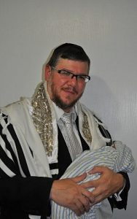
Rabbi Elisar Admon, mohel. (Rabbi Elisar Admon/File)

“We hope that by early next week, we will be allowed entry to the main floor and the upper floor,” Rabbi Admon told Hamodia. “The FBI will inform us when their work is finished, and we will continue our work until we are satisfied that we have completed our obligations. The building will probably remain closed to the public at least to the end of next week.”
As an afterthought, Rabbi Admon mentioned that on Tuesday morning, he performed a bris at Kollel Beis Yitzchok, the kollel of Pittsburgh established by Bais Medrash Govoha of Lakewood. “It was very emotional, and I thought of the passuk which says ‘bedamayich chayi - I will live through my blood’. This passuk is interpreted to be a reference to bris milah. I couldn’t help but think about the bloodletting in our city, and how we are now celebrating with the blood of bris milah.
“We were informed by the FBI that we could enter the basement at 9:00 AM that morning. I told them that due to the bris, we would only be able to arrive at 11:00. When I arrived, the FBI agent in charge hugged me and marveled how we could go from a joyous occasion to such a sad scene. I explained that as Jews, we were trained to adjust according to the needs of the times.”
As a nation, Jews throughout the country and the world are mourning together with the Pittsburgh Jewish community. And as a nation, the souls of the kedoshim will enable us to celebrate the milestones of the future.

Printed from the November 1, 2018 edition of Hamodia.

Ancient Torah Scroll is
Safe After Fire Engulfs an Iconic Museum in Brazil
By Marcus M. Gilban

A view of the fire at Brazil’s National Museum, Sept. 2, 2018. (Tania Rego/Agencia Brasil)

RIO DE JANEIRO (JTA) — An ancient Torah scroll once owned by a Brazilian emperor had been removed from Brazil’s National Museum for restoration prior to the massive fire that engulfed the building in Rio on Sunday.
Unlike other irreplaceable treasures, the 13th-century Yemenite Torah scroll once owned by emperor Pedro II is safe at another building that belongs to the National Museum. The Jewish federation in Rio is expected to make an announcement about the Jewish artifact soon.
“We deeply regret the loss of this colossal treasure in the history of Brazil,” Israel’s honorary consul in Rio, Osias Wurman, said of the building in an interview with JTA. “The only compensation was to know that the Torah of Pedro II is safe, since it was located in another building of the museum. This Torah is evidence of the admiration that the Portuguese monarch had for the Jewish people and for their traditions. This was so rare in Europe.”
The National Museum housed Latin America’s largest collection of historical artifacts with over 20 million items, including extensive paleontological, anthropological and biological specimens. It was home to a 13-yard-long dinosaur skeleton, an Egyptian mummy and a skull called Luzia that was among the oldest fossils ever found in the Americas, which were all burned in the fire. The largest meteorite ever discovered in Brazil survived the flames.
Established in 1818, the museum’s building was once the home of the Portuguese Royal Family after it fled Napoleon’s troops and sailed to Brazil. It was later home to the Brazilian Imperial Family until 1889. Pedro II, the country’s last monarch, was born there in 1825.
The cause of the fire is still not known. Protesters and museum directors said years of government neglect had left the museum so underfunded that its staff had turned to crowdfunding sites to open exhibitions.
Emperor Pedro II was the grandson of Portuguese King Dom Joao VI. He established a reputation as a vigorous sponsor of learning, culture and the sciences. A passion for linguistics prompted him throughout his life to study new languages, and he was able to speak and write not only Portuguese but also another 13 languages, including Hebrew.
In May, a sefer haftarah — or readings from the books of the prophets that are read on Shabbat following the Torah reading — was seized from criminals during a police raid of a Rio slum and returned to the Jewish community.
Marcus M. Gilban is JTA's correspondent in Rio de Janeiro. A freelance journalist and columnist, he contributes to Brazilian Jewish newspapers, magazines and news portals.

Reprinted from the September 4, 2018 email of the Jewish Standard.

Weekly Chasidic Story #1066

The Silent Storyteller
From the Desk of Yerachmiel Tilles

Before the Baal Shem Tov passed away he called all of his main disciples to his bedside and spoke to each one individually. He told each one what occupation he was to undertake in the future and how he was to behave. Last of all, he called his devoted student and attendant, Yaakov, to him and said:
"You, Yaakov, are to travel about telling stories about me. This will serve you as your means of livelihood as well, for people will pay you to hear such incidents and happenings."
"But Rebbe," protested Yaakov, "is that to be my aim in life, to be forever wandering and to tell stories?"
"Don't you worry. You will be rich from this, with G-d's help"
The Baal Shem Tov passed away. All the disciples fulfilled his last instructions and Yaakov, too, went forth to visit settlements and villages to tell tales of the Baal Shem Tov as he had witnessed them, earning a handsome income to the bargain.
After two and a half years of such an existence Yaakov head that there was a certain wealthy man in Italy who paid a valuable gold coin for each story he was told about the Baal Shem Tov. He rejoiced at this information for with his wealth of stories he felt he could earn enough to let him stay home for a year or so.
As soon as he was able, he bought himself a horse and wagon, hired an assistant, and set forth on the long trip to Italy. The voyage took him seven months, for he was forced to stop at the villages and towns along the way in order to earn enough to cover his expenses.
When he entered the city of his destination he asked around to find out what sort of a person this wealthy man was.
"Oh, he is a man of great means," he was told. "He holds court like a king, though he himself is a pious and righteous man. He spends all his time in study and prayer for he has faithful employees running his business for him. And every Shabbos, at the Third Meal, he has someone tell stories about the Baal Shem Tov. He later pays a gold coin for each story told!"
"Where does this man come from?" asked Yaakov curiously.
"No one really knows. He came here about ten years ago and bought himself a mansion with expansive grounds. He built himself a Beit Midrash on his property which is open to the public for daily prayers. And on Shabbos he invites half of the city to join him at his table!"
Yaakov told his attendant to go to this rich man and announce that his master, a former close disciple of the holy Baal Shem Tov, had just arrived in town. The servant was told that his master was very welcome to spend Shabbos in the mansion, during which time he would have many opportunities to tell all the stories that he knew of the Baal Shem Tov.
The Jews of the town were overjoyed to hear of the arrival of a master storyteller. They all gathered at the Shabbos table of the rich man after their own meals to listen avidly to the stories that Yaakov had to offer. After the traditional Shabbos night songs, the host finally turned to his important guest and nodded to him to commence.
Yaakov opened his mouth to speak but nothing came out. Suddenly the strangest sensation had come over him and he actually went blank. He forgot everything that he had ever known concerning his rabbi. He tried desperately to reconstruct an image of his rebbe before his mind's eye so that he might better recall some incident of his life, but he couldn't even remember any of his features. He tried to recall all the places that he had visited with his rebbe, but even his most supreme efforts were of no help.
He was utterly confused and helpless; he sat at his place with downcast eyes and a fallen countenance.
The townsfolk who had expressly come to hear his tales began whispering to one another, hinting that he was really a fraud, that he only sought a free meal and had never in his life seen the Baal Shem Tov. But the host, most disappointed of all, contained himself and said:
"We will wait until tomorrow. Maybe until then you will remind yourself of some incident."
That night Reb Yaakov wept in bed. He struggled to conjure up an image of his rebbe's face or even the faces of some of his friends, the Baal Shem Tov's disciples, but it was as if he had never seen the Baal Shem Tov at all. His mind was a complete blank; every trace of those former days was completely erased from his memory.
On Shabbos day the whole city had again gathered at the rich man's table, this time out of curiosity, to see if the guest had recovered his memory and had any stories to tell of the Baal Shem Tov. They suspected him more than ever of being a fraud, and when their host nodded to his guest after the zemiros, the guest only shrugged his shoulders hopelessly with tears in his eyes.
"Believe me", he said pathetically, "such a thing has never happened to me before! This is a most unusual occurrence".
What could be the reason for this unusual loss of memory - wondered the perturbed Yaakov all the Shabbos. Is it maybe because I ventured out of my familiar territory? The Baal Shem Tov said that I was to travel among the villages and cities where he had been known, where people had heard of the Baal Shem Tov and desired to hear more.
Yaakov spent the whole day in tearful prayer seeking a solution to his dilemma.
At the Third Meal, the rich man's house was packed. Everyone had come to scorn the faker who had dared to take advantage of their benevolent host. They teased him and jeered at him but he took it all in his stride.
However, that evening after the havdala ceremony signaling the end of Shabbos, Yaakov went to the rich man to bid him farewell. "I can no longer avail myself of your gracious hospitality. I have been prevented by heaven from telling any of the many stories that I know of my rebbe and have no excuse to remain. I therefore beg your forgiveness and seek your permission to leave."
"Please remain until Tuesday," his host urged him. "Give yourself another chance. It may be that the trials of your journey have made you temporarily forget. Your memory may yet return to you. Stay until Tuesday and then we shall see."
Yaakov reluctantly prolonged his stay. But he did not remember anything in the interval and when Tuesday finally arrived he again sought his host. "I thank you kindly for your gracious hospitality and beg forgiveness for the embarrassment I have caused you. Please let me go now."
The wealthy man gave Yaakov a generous donation and bade him farewell.
Yaakov took his place in his wagon and signaled to his attendant to drive. But as soon as the horses began trotting he shouted at him to stop the wagon.
"I remember! I remember!" he screamed excitedly as he jumped down and ran back to the rich man's house.
The rich man was waiting for him and begged him to tell his story.
It happened, he began, once just before the gentiles celebrated their Easter. That Shabbos the Baal Shem Tov seemed most upset and tense, continuously pacing back and forth. Immediately after Shabbos he had Alexei, his customary driver, prepare the wagon. He took along with him three of his close followers, including myself. We sat in the wagon and traveled all that night. When we reached our destination in the morning, the horses stopped of their own accord at a large house in a big city.
The windows and doors were tightly barred but the Baal Shem Tov told me to knock nevertheless. An old woman peered out and shouted angrily:
"What are you doing here now? Are you all mad? Do you want to be murdered? Don't you know that today the gentiles kill any Jew who is out on the streets! Today is the day that they take revenge on the Jews who they say killed their god. If they find out it will be tragic for you and we will also suffer the consequences. Now hurry, get out of town while you still can!"
The Baal Shem Tov gently urged her aside and entered, ushering us after him and closing the door behind us all. The members of the household were huddled together, speechless with fright. The old woman began ranting and raving against the Baal Shem Tov but he paid her no heed. He took his position by a window, moved the curtain aside and looked out. The woman shrieked that he was bringing destruction upon them all.
The Baal Shem Tov could see the city square from his vantage point. He saw a high platform with thirty steps erected in the center and a mob of people already assembled, waiting for the bishop. The bishop's address was the signal for the rampage, bloodshed and havoc that was annually wrought upon the lives and property of the Jews of the city.
Soon the sounds of bells announced the coming of the bishop's procession. The Baal Shem Tov watched the procession advance until the bishop finally took his place at the podium on the platform. Then he turned to me and said:
"Yaakov, go to the bishop and tell him to come to me immediately!"
When the members of the household heard these words they were shocked. "How can you send a man to his slaughter! Why, that bloodthirsty mob outside will rip him apart limb from limb!"
But the Baal Shem Tov paid them no heed and just told me to do as he had bidden, and to hurry.
I had implicit faith in my master for I had seen him perform great wonders and miracles in the past and I went forth fearlessly to do his bidding. And wonder of all wonders, the mob ignored me. I passed through them unharmed and untouched. I reached the central platform and climbed up the thirty steps while all was silent.
I went boldly up to the bishop and delivered my message.
"The Baal Shem Tov is here and he summons you to come immediately."
"I am aware of his presence," answered the bishop. "Tell him that after I have finished my speech I will come to him."
As I returned to the house I could see all the Jews peering out with baited breaths, from cracks and slits, while I threaded my way back. I delivered the message to the Besht and he answered angrily:
"Tell the bishop that he must come instantly, without further delay! Tell him not to be a fool!"
When I made my way back to the platform the bishop had already commenced his address. I tugged at this robe and repeated the words of the Baal Shem Tov. The bishop listened and then turned to his audience.
"Please excuse me. I shall presently return."
The bishop followed me down the steps and back to the house. When we entered, the Baal Shem Tov took the bishop aside into another room, and was closeted with him there for two hours. When the rebbe emerged from the room, he ordered the wagon prepared and we journeyed back home.
This took place about ten years ago and to this day, I don't know what transpired between them or what happened afterwards with that bishop.
It's very strange, mused Yaakov, that I haven't remembered this story all these ten years until today.
"Praise be to G-d," said the rich man lifting his hands upward in thanksgiving. "I can testify to the truth of your story. The moment that you came to me I recognized you but I was silent. Now I shall tell you the end of the story.
"I am the very bishop in your tale! I had converted from Judaism, tempted by the lure of false knowledge. I was saved in the end by the merit of my ancestors who were saintly men. They begged the Baal Shem Tov to help me. They appeared to me in a dream as well, beseeching that I return to the fold. I promised them that I would run away the next morning, before the crowd assembled.
"But when the morrow dawned I was again swayed by my evil inclination. I saw all the people gathered, waiting for me to address them. I also saw that the Baal Shem Tov had arrived and I was undecided. When the church bells began chiming I found myself walking to the central platform. I felt that I could not disappoint the crowd that was waiting for me. I could not forego all the honor and glory that went with my position.
"When you called to me the first time, I was still in the clutches of my evil inclination. But when you came the second time…I suddenly became another person. I followed you to the Baal Shem Tov and he showed me how I was to repent.
"I subsequently gave half of my fortune to the poor and a quarter of it to the king that he might permit me to leave the country upon some pretext that I had given him.
"The Baal Shem Tov gave me a sign at the time. He told me that if someone were to come and tell me this very story - I would know that my repentance had finally been accepted. When I first saw you in my house I was overjoyed, for I remembered you. But when I realized that you had forgotten the incident, I knew that heavenly intervention had prevented you from remembering.
"All the time that you stayed by me, I prayed and repented and was finally rewarded now when you returned to tell me this very story.
"You will no longer have to continue your wandering. I shall shower you with gifts and money that will last you for the rest of your life."
~~~~~~~~~~~~~~~
Source: Lightly edited and supplemented by Yerachmiel Tilles from the English edition of Tales of the Baal Shem Tov (vol. 2) by Y. Y. Klapholtz , as translated by Sheindel Weinbach
Biographical notes: Rabbi Yisrael ben Eliezer [of blessed memory: 18 Elul 5458 - 6 Sivan 5520 (Aug. 1698 - May 1760 C.E.)], the Baal Shem Tov ["Master of the Good Name"-often referred to as "the Besht" for short], a unique and seminal figure in Jewish history, revealed his identity as an exceptionally holy person, on his 36th birthday, 18 Elul5494 (1734 C.E.), and made the until-then underground Chasidic movement public. He wrote no books, although many works claim to contain his teachings. One available in English is the excellent annotated translation of Tzava'at Harivash, published by Kehos.
Connection: This Shavuot is the 258th yahrzeit of the Baal Shem Tov.

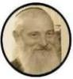
Yerachmiel Tilles is co-founder and associate director of Ascent-of-Safed, and chief editor of this website (and of KabbalaOnline.org). He has hundreds of published stories to his credit, and many have been translated into other languages. He tells them live at Ascent nearly every Saturday night.

Rose Zar, a Holocaust Survivor Who Hid in Plain Sight
By Melissa Eddy

Zar worked in the home of a Nazi commander and saved dozens of Jewish orphans, then moved to the United States and shared her life story.
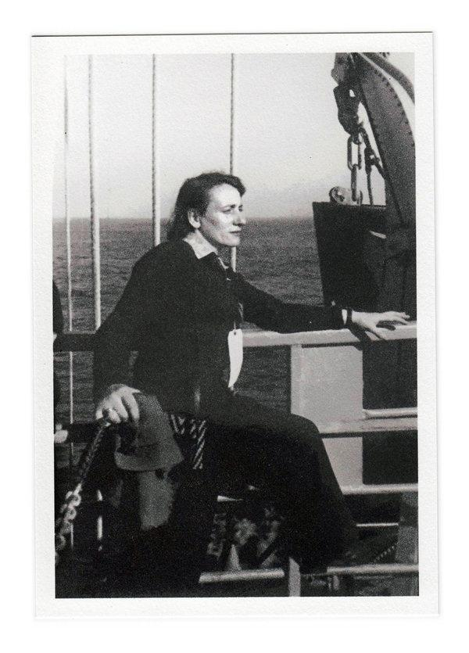
Rose Zar worked in the home of a Nazi commander during World War II, hiding her Jewish identity. Photo CreditCredit via Howard Zar

Unlike Anne Frank and thousands of other Jews who spent all or part of World War II sequestered in attics, caves or sewers, Rose Zar survived the Holocaust by hiding in the open.
In October 1942, when she was 19, her father feared that the Nazis were closing in on the ghetto where they lived, in Piotrkow, Poland. Zar, who had been part of the Jewish resistance before the war broke out, was prepared. She grabbed her suitcase and forged passport and left her family behind.
For the next three years, she would move around Poland, disguising herself as a Roman Catholic named Wanda Gajda. She relied on a mix of courage, intelligence and moxie to get herself out of delicate encounters with suspicious Poles who, she later said, would “turn a Jew in for a liter of flour.”
Ruszka Guterman was born in Piotrkow on July 27, 1922. Her father, a leather craftsman who ran a shoe factory, told her that if she ever had to go into hiding, the best place would be the most obvious, where those pursuing her would never look.
“He said you have to hide in the mouth of the wolf, under the officials’ nose,” Zar told the USC Shoah Foundation in 1996, “and watch that they don’t devour you.”
Although she had earned a teaching certificate before leaving home, Zar was forced to find menial jobs like cleaning the stairs in a hospital or peeling potatoes in the kitchen of the local SS headquarters in Krakow. To keep out of trouble, she learned to laugh at the crude, often anti-Semitic jokes told by the Polish women she worked with.
“I figured it like this,” Zar said in the Shoah Foundation interview. “You are born in the wrong times in history. You are an actress. You have to play your role good, because you pay one price. It is your life.”
When an SS commander summoned her to his office for questioning, she felt certain that it was the end. She answered his queries, telling about her experience as a nurse and how she had learned to speak German fluently. Several days later, she was introduced to the commander’s wife. The encounter she had feared turned out to be a job interview. She spent the final years of the war as her father had advised, hiding in plain sight in the home of a Nazi commander as “Fräulein Wanda.”
Her position afforded her luxuries: silk stockings borrowed from the commander’s wife and front-row seats to theater performances of “Faust” and “Der Rosenkavalier” intended only for Germans. Yet every day she concealed 50 Polish zlotys and her passport beneath her clothes in case she had to flee. She always had an escape route in mind.
“In many ways she was very fearless and very much ahead of her time,” her son Howard Zar said.
Decades later, she again drew on her father’s advice for the title of her memoir, “In the Mouth of the Wolf.” Written with Eric A. Kimmel and published in 1983, the book won the Association of Jewish Libraries’ Book Award and is taught in schools across the United States.
Howard Zar recalled receiving a letter from a student who had read his mother’s memoir in class and summed up her spirited determination in more modern terms, praising her “as ‘a “downright gangsta.’ ”

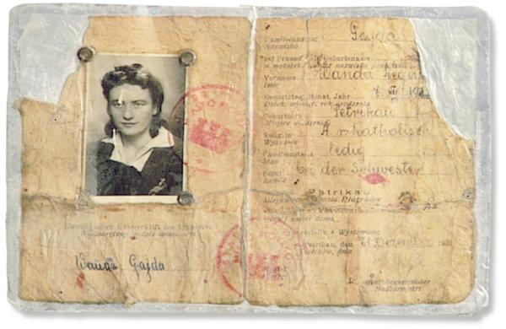
Zar’s fake papers identifying her as Wanda Gajda.CreditRose Zar

Once the Russians had chased the Nazis from Poland, Zar set up typing classes for young women in Krakow on the machine that she had taken with her from the commander’s home.
After the war, she was reunited with her brother, who had also survived by concealing his Jewish identity, and her sweetheart from when she was a teenager, Mayer Zarnowiecki, a survivor of the Theresienstadt and Buchenwald concentration camps. They married in September 1945. (They later moved to the United States, where they shortened their last name to Zar.)
When violence broke out against Jewish refugees in the Polish city of Kielce, Zar and her husband decided it was time to leave. They helped smuggle 139 Jewish refugee children with them through Czechoslovakia and into southern Germany, where they helped set up a school run by the International Refugee Organization and the United States Army.
There, Zar taught orphans about their Jewish identity and helped them regain confidence. The International Refugee Organization praised Zar in a letter of recommendation for her “intensive devotion” to the children’s welfare “and much sacrifice of personal time to achieve the best results.” The children were resettled in Israel, many aboard the Exodus, a refugee ship memorialized in book and film after the British turned it away from Palestine in 1947 with 4,500 Holocaust survivors and other refugees onboard.
She and her husband moved to South Bend, Ind., where they had two sons and a daughter. There, she taught Hebrew and prepared Jewish children for their bar and bat mitzvahs. She later became the head of Jewish education for the Jewish Federation of South Bend.
Although neither she nor her husband came from particularly strict homes, they began keeping kosher and following the Sabbath. They also gave talks around the country about their stories of survival from the Holocaust.
Zar died on Nov. 3, 2001, in South Bend. She was 79.
Kimmel, the co-author of her memoir, remembered first talking to Zar about her life. He had been working on a Holocaust-themed novel for young readers and began asking Zar for details about her experiences. Once she began recounting her story, he realized it was better than anything he could invent. He offered to help her write it, and she agreed, on condition that the story remain hers and that she be allowed to review every word.
“What makes the story unique is that it tells about a one-of-a-kind experience,” Kimmel said. “It doesn’t see the world in black and white. Treacherous Jews. Likable Germans. Heroic and despicable Poles. The human panorama is all too real. It holds up a mirror. What would we do? How would we choose?”
While in Poland during World War II, Zar was forced to remain silent about her identity. Later, she felt compelled to break that silence.
“‘Of course we must talk, we must tell the stories. Otherwise, they will be forgotten and the enemies will have won,’ ” Kimmel recalled her saying. “‘ I must talk about it. It is my duty to talk about it. If I don’t tell my story, who will?’ ”

Reprinted from the October 24, 2018 website of The New York Times.

Meet the Sheitel Fairy Godmother, Providing Wigs To Needy Orthodox Women
By Jenny Powers

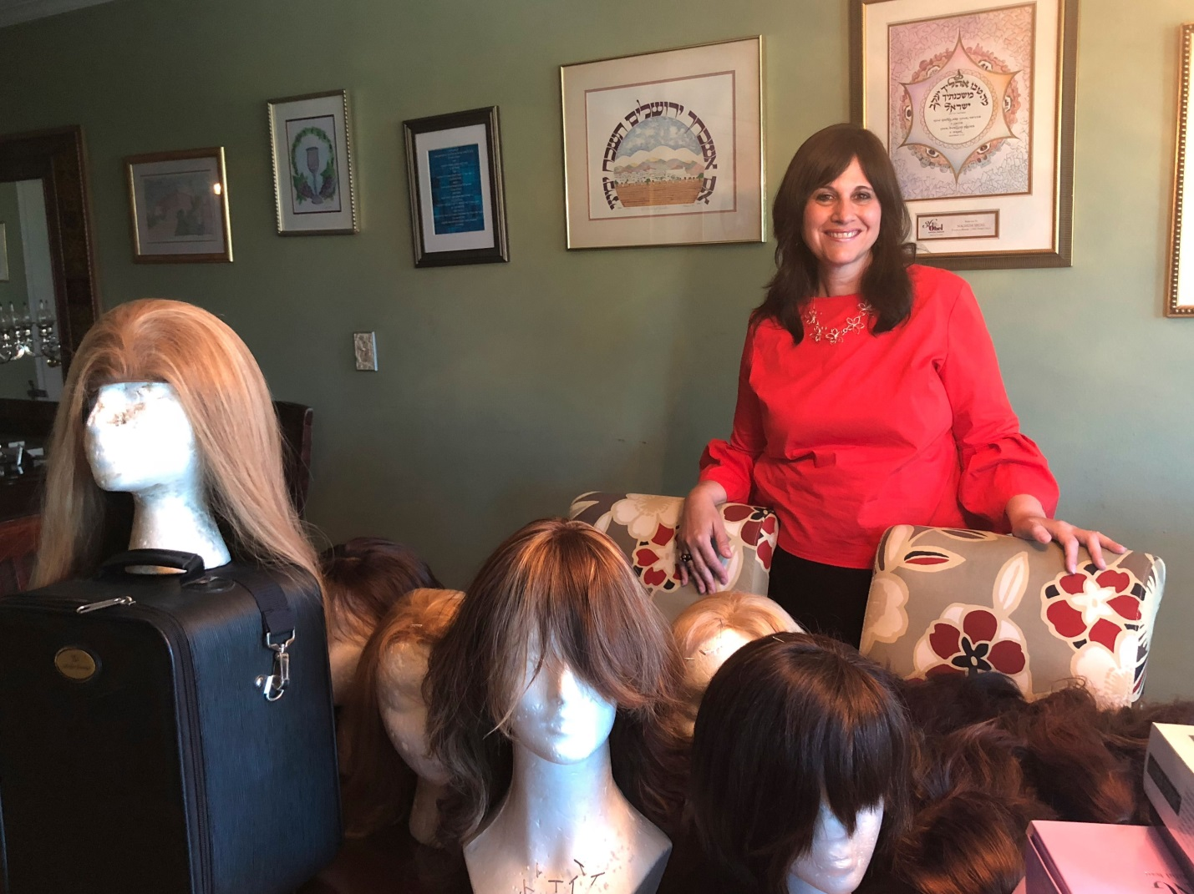

Staci Segal is on a mission to get sheitels, the wigs worn by married Orthodox women, into the hands and onto the heads of those that do not have the means to afford them.
According to Segal, the starting cost for a decent sheitel made of human hair, the preferred material starts at $500 and goes up to a staggering $6000, making it unaffordable for many, like the widow who didn’t have a decent wig to wear to her own son’s wedding, the newly converted bride, or the desperate woman caught in a last-minute bind when her only sheitel turned out to be covered in lice just hours before she was due at an wedding.
That’s where Segal comes in.
She calls it The Sheitel Shuffle, a dignified exchange.
“Bring me a sheitel in any condition and take one in exchange, there are no judgments here,” stresses Segal, mother of six (including triplets).
Married for nearly thirty years, Segal, born and raised on Manhattan’s Lower East Side, is a public school teacher in the neighborhood. Two years ago, while meeting up with an old friend in the park, she couldn’t help but notice her friend’s sheitel was in serious disrepair. The woman shared that despite the condition of her wig, money was tight and it was not in her family’s budget to buy a new one so she’d managed to cover the holes by wearing a hat.
That got Segal thinking of all the women out there that probably had old sheitels they no longer wore sitting in the back of their closet and from that day forward Segal says, “Everywhere I went, weddings, Bar Mitzvahs, even Glatt Mart, I began approaching women asking if they had any sheitels they might consider donating.
“I WhatsApped everyone I knew and posted on Facebook to get the word out. I even had business cards designed and began handing them out,” Segal says standing in front of her family’s dining room table whose surface is completely covered in a generous array of sheitels of every style and color.
While The Sheitel Shuffle may have been Segal’s idea, the effort has very much become a family affair. Her daughters regularly solicit donations from their friend’s mothers, her sons make sheitel pick-ups and drops in school lobbies and even kosher deli counters. Her husband Nachum Segal, a well-known radio personality in the Jewish community even does public service announcements on his Internet radio program to do his part.
Collecting sheitels is only the first part in the process though. Upon acquisition, each sheitel is hand-washed and set by self-taught volunteers like Segal’s daughters or one of the other young girls in the neighborhood who volunteer. There’s even one local girl teaching herself how to do repairs.
From there, each wig is photographed and categorized by color and length and stored in Segal’s apartment.
Segal says she manages to have an inventory of between 50-60 wigs on hand at any given time, citing her busiest times as right before the High Holidays, noting red wigs are hard to come by and there is always a need for blonde ones since there are so many different shades. There is never a shortage when it comes to demand though according to her count, “No one has ever come in for a wig and left empty-handed.”
Local women are welcomed into Segal’s home by appointment to try on wigs and select one to take home. Those that don’t live locally correspond with her via email, making their selections through photographs and then covering their own minimal shipping costs.
Segal has become somewhat of a fairy godmother, coming to the rescue of women in need of a sheitel and restoring their confidence in the process.
“You know how you can buy a car that’s a lemon? Well I managed to buy a sheitel that was a lemon, and the woman I bought it from wouldn’t let me return it,” sighs an exasperated Spring Valley woman who shelled out $800 for a defective sheitel whose hair was sewn in upside down causing it to appear frizzy after a brushing.
“I was in between jobs and there was no way I could tell my husband I needed a new sheitel, so I just kept on wearing it. One day I was walking across the Williamsburg Bridge to meet Staci for lunch when a deluge of rain came out of nowhere. I was sopping and by the time I reached Staci my sheitel was completely ruined.
“That was the day Staci told me about her project, The Sheitel Shuffle. She let me go through all the wigs she had, and I got a new one right there and then. It was so unexpected and was the most perfect timing. It gave me the confidence I needed to start a new job. It’s a big commitment to buy a sheitel and having a nice one makes a huge difference,” she says proudly.
Sara Oppenheim, a resident of North Carolina, agrees. “A man in our community lost his job when his company downsized and it was a challenge to buy his wife a new sheitel. Everyone wants to look their best and it’s especially important when you’re going through tough times and you don’t feel your best,” she says recalling a trip to New York where Segal arranged for her neighbor to meet Oppenheim in a local park to drop off a sheitel since she was out of town. “Staci is a doer, she wants to make the world a better place.”
“In the best case scenario, a woman has three sheitels: One for every day, one for Shabbos and one for weddings. Not everyone is that fortunate though, admits Segal. ”I’m like that table in the laundry room where people leave things for others to take when they are done using them, except it’s a lot more work!” She smiles. “This is not about charity though. There is no shame in sharing. This is an exchange and I happen to be the home for it.”
To learn more about The Sheitel Shuffle and how you can participate in the exchange, email Sheitelshuffle@gmail.com.

Reprinted from the July 26, 2018 email of The Forward.

In Japan, I Discovered the Unsung Dutch Hero Behind Sugihara’s Rescue of Jews
By Cnaan Liphshiz

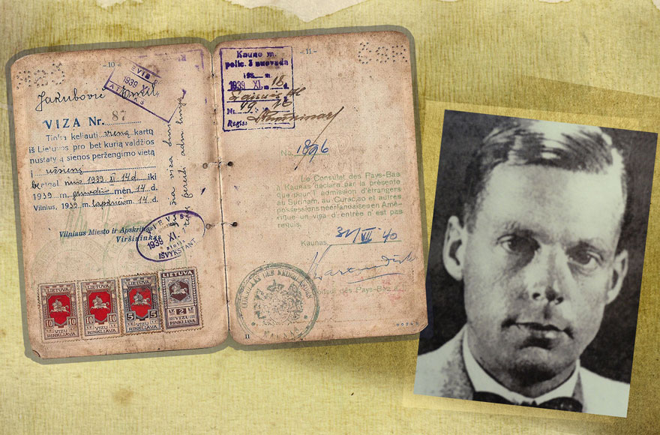
Jan Zwartendijk and a visa he signed in 1940. (JTA collage/Wikimedia Commons)

YAOTSU, Japan (JTA) — Like other journalists and researchers, I traveled all the way to this rural area to gain a better understanding of the actions of Chiune Sugihara, one of the most extraordinary rescuers of Jews during the Holocaust.
But unlike most foreign journalists, my October visit to the museum dedicated to this Japanese diplomat — he issued over 2,000 transit visas to Jewish refugees trapped in Kaunas, Lithania — led me to focus on an overlooked and arguably more dramatic element of the Sugihara story. Ironically, that story was waiting for me all along back in my home country of the Netherlands.
At a museum in what many believe to be his Japanese hometown, Sugihara, who died in 1986, is celebrated as a hero for defying orders from Tokyo and, while posted to Kaunas (Kovno) in 1940, helping Jews flee the Nazis and travel through Russia on to China, Japan and beyond.
A rare embodiment of benevolence in a pro-Nazi government that was complicit in some of the worst war crimes in human history, Sugihara is also among the very few to receive the State of Israel’s honor of Righteous among the Nations even though he did not risk his life to save Jews during the Holocaust.
Ending decades of relative obscurity and ambivalence in Japan toward Sugihara — his reputation may have suffered in the country’s hierarchical society over his disobedience — his story of rescue in recent years has become one of the best-known accounts of its kind. Visitors and journalist come by the thousands to the museum, a standard-looking institution erected in 2000 by the government in the village of Yaotsu in the Gifu District. (The area’s other claim to fame is its exquisite sake, a traditional alcoholic beverage made of rice).
The museum is housed in a large wooden building with an adjacent peace monument featuring a fountain and a shrine. The complex crowns a hill overlooking a lush green valley that at sunset echoes with the calls of the red-breasted Japanese sparrowhawk.
At the very end of my tour of the exhibit, I noticed a poster about other life-saving diplomats. It mentioned, in exactly 50 words, a Dutch businessman and diplomat named Jan Zwartendijk.
Zwartendijk served in Kaunas as consul at the same time that Sugihara was there to represent Imperial Japan. Largely eclipsed by his Japanese counterpart, Zwartendijk was the initiator and chief facilitator of the rescue associated with Sugihara. And unlike Sugihara, Zwartendijk risked his own life, as well as those of his wife and their three small children.
According to the enigmatic text on the poster, Zwartendijk gave “Jewish refugees quasi-visas,” which together with the ones issued by Sugihara allowed them to escape.
Feeling more confused than educated, I called Efraim Zuroff, a Holocaust historian affiliated with the Simon Wiesenthal Center who wrote about Sugihara in his doctoral thesis.
“Listen to me,” Zuroff told me in his Brooklyn accent, “there would’ve been be no Jewish refugees in Japan if it weren’t for Jan Zwartendijk. He started the whole thing. Without him, Sugihara could never have given visas. Zwartendijk deserves a lot more credit than he got. His role was absolutely crucial, every bit as that of Sugihara, who is far better known.”
Before Sugihara gave them transit visas, Zwartendijk gave the same Jewish refugees destination visas to Curacao, then a Caribbean island colony of the Netherlands.

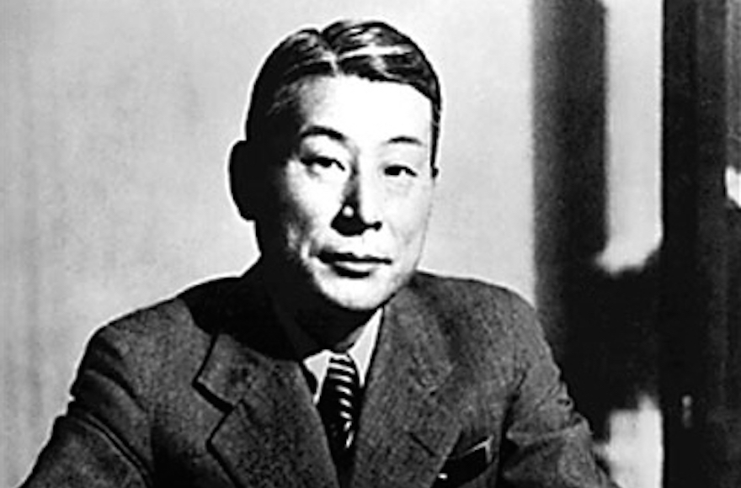
Chiune Sugihara, a Japanese diplomat, helped thousands of Jews flee Europe during World War II. (Wikimedia Commons)

The flight of Jews from Lithuania to Japan began in October 1940, after the Red Army and Adolf Hitler’s Nazi Germany carved up Poland and the Baltic states. Thousands of Jewish refugees crossed over to Lithuania in the wake of the Nazi and Soviet occupations of Poland.
At least one of them, Peppy Sternheim Lewin, was a Dutch citizen. So she reached out to the Dutch ambassador in Latvia, L.P.J. de Dekker, asking if she could get a visa with her Polish husband to the colonies. De Dekker told her that Curacao was a visa-free destination with admittance at the discretion of the governor. So Lewin — her granddaughter described her as having “chutzpah” in a 2016 op-ed for JTA — asked de Dekker to write this in her travel document but to omit the part about the governor’s discretion, which de Dekker did.
This gave the first of the people known as the Sugihara refugees their first destination visa. When word got out, Zwartendijk, who was de Dekker’s friend and appointee in Kaunas, gave the same visa to some 2,300 people stuck in Kaunas without consulting any of his superiors.
But to head eastward, the refugees still needed to go through the Soviet Union, which would not admit them on the basis of the Dutch destination visa alone. Which is where Sugihara comes into the picture, according to Zuroff. Consulates were packing up following the Russian invasion, Zuroff explained.
“So all the people with Curacao destination visas, they start showing up at the office of Sugihara, who introduced himself by his nickname, Sempo,” Zuroff said.
Decades later, the nickname would complicate efforts to locate Sugihara by people he helped save, the director of Yaotsu’s Chiune Sugihara Memorial Hall, Daisaku Kunieda, told me.
“When they approached the Japanese Foreign Ministry, Tokyo had no idea who Sempo was,” Kunieda said.
Many people in Japan and beyond believe the Japanese authorities were not interested in advertising Sugihara’s disobedience and that he was even dismissed from the Foreign Service in 1947 for it. But whereas Sugihara was certainly not celebrated at first for his actions, talk that he was disciplined is exaggerated, according to Hanit Livermore, an Israeli ex-employee of the museum who moved to the Gifu District to work there.
“It was a time of a major reshuffle in the Foreign Ministry and many other diplomats were laid off,” said Livermore, 48, who moved to Japan with her Israeli husband about 20 years ago. Plus, Sugihara was given a second and third posting after word got out about the refugees he helped save.
Back in the Netherlands, the Dutch government also did little to celebrate the actions of Zwartendijk, according to his youngest son, Rob.
“My father wasn’t a real diplomat, he was someone from the outside who basically abused his diplomatic powers, and that’s apparently not something the Dutch Foreign Ministry is or has not been very keen on celebrating,” he told me in a café near Amsterdam.
“Not really, they were working independently, but of course they knew of one another’s actions in a small city like Kaunas,” Rob Zwartendijk told me. In their one direct exchange, Sugihara phoned the elder Zwartendijk to ask that he slow down the rate at which he was handing out destination visas. The reason: Zwartendijk had a stamp, whereas Sugihara had to write each visa by hand.
Were Zwartendijk and Sugihara working together in Kaunas?
Witnesses say Sugihara was still writing transit visas inside the train after he was ordered by Tokyo to leave Kaunas.
Shortly after the Jewish refugees and Sugihara left Kaunas, so did Zwartendijk, who returned with his wife and three children to the Nazi-occupied Netherlands to continue working for Philips, an electronics and appliances manufacturer. Until the Netherlands was liberated in 1945, the destination visas he gave out were a dangerous secret that, if made known, could have sealed the fate of Zwartendijk’s entire family, his son said.

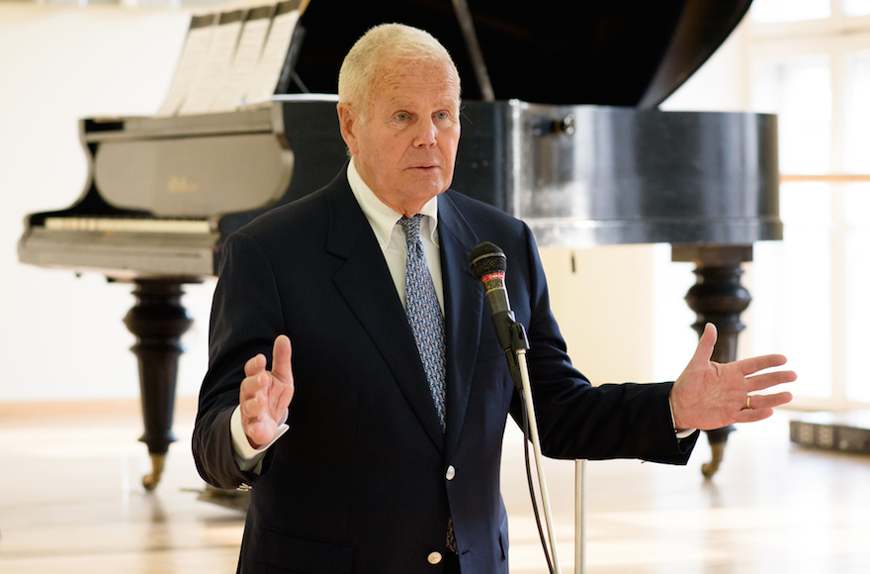
Rob Zwartendijk speaking at a ceremony in honor of his father, Jan, in Vilnius, Lithuania, April 29, 2016. (Courtesy of the Jewish Community of Lithuania/LZB)

Were Zwartendijk and Sugihara working together in Kaunas?
“In the first few years it was a matter of security that could meant a ticket to a concentration camp and death,” said Rob Zwartendijk, a 78-year-old retired business executive.

Reprinted from the January 9, 2018 dispatch of the JTA (Jewish Telegraphic Agency.)
Youth Raised as Muslim in Eastern Jerusalem Discovers He's Jewish
By Arutz Sheva Staff

Arab school in eastern Jerusalem (Flash90)

“Shmulik” (invented name) is a youth who grew up in eastern Jerusalem as a Muslim, and who even wanted to become a “shahid” - until, one day, he was surprised to discover that his mother was Jewish - making him a Jew himself.
Speaking with Channel 2’s Rina Matsliach, Shmulik explained, “I grew up in eastern Jerusalem to a Jewish mother and an Arab father.”
When he was still young, however, his mother died and his father remarried to an Arab woman.
“I grew up with the wife of my father, I was there almost 16 years, not knowing how my mother died and where her parents are.”
Shmulik related that he began working in repairs, during the course of which he met a Jewish plumber - a meeting which changed his life.
The plumber asked Shmulik for his ID number and, after several inquiries, told Shmulik that he was, in fact, Jewish.
Two weeks later, Shmulik turned to the anti-assimilation organization Yad L’Achim.
Shmulik has since cut off contact with his family, and has completely changed his lifestyle. “It’s a really difficult change - I went through a lot of challenges. Even today, there are people who can’t accept it,” he said.
Nevertheless, Shmulik said that he is committed to the path he has chosen. Rabbi Yoav Ze’ev Robinson of Yad L’Achim has been assisting Shmulik on his new journey, even arranging a meeting between Shmulik and [his Jewish] grandmother.
“I went into my mother’s room, it was really exciting - I felt like her soul was there,” Shmulik related.
“There’s no going back, I [now] have connections with many good people,” he concluded.

Reprinted from the February 1, 2018 email of Arutz Sheva.

EUROPE | AMSTERDAM JOURNAL

New Slaughtering Rules Pit Dutch Religious Freedoms Against Animal Rights
By Nina Siegaldec

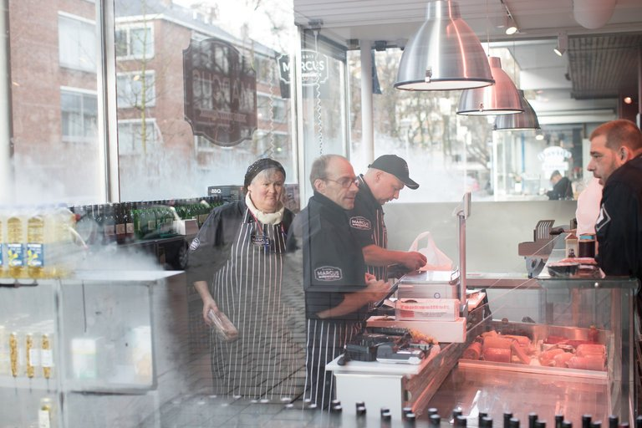
The Slagerij Marcus kosher butcher shop in Amsterdam. Jewish and Muslim groups have agreed to change ritual slaughter practices in the face of pressure from animal rights activists. CreditJasper Juinen for The New York Times

AMSTERDAM — For 60 years, the Sal Meyer deli in Amsterdam has been serving kosher foods like its signature pekelvlees, a fatty corned beef steeped in meat juices and served with a bun.
The deli is one of the few kosher restaurants left in Amsterdam, a city that once had such a vibrant Jewish community that it still retains the nickname Mokum, the Yiddish word for “safe haven.” People travel from miles away to meet their friends there, and the deli holds a small community together in a country where 80 percent of the Jewish population was killed during World War II.
“This is a very important place for the Jewish community, and the fact that we have the meat that is still approved by the rabbi is an important thing for our customers,” said Martijn Koppert, a co-owner of the restaurant. “It’s really part of the community life.”

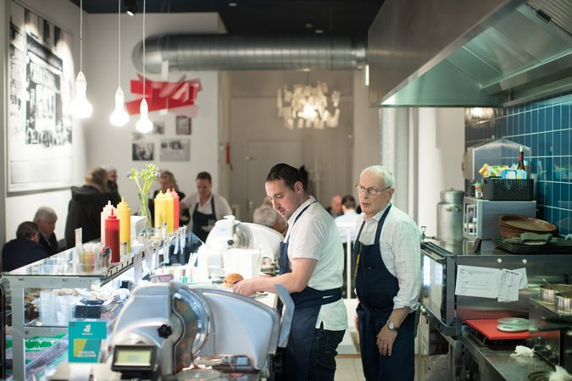
The Sal Meyer deli is one of the few kosher restaurants left in Amsterdam. “That we have the meat that is still approved by the rabbi is an important thing for our customers,” an owner said.CreditJasper Juinen for The New York Times

But starting Monday, keeping customers satisfied may get more difficult, not just for Sal Meyer but also for kosher and halal butchers across the Netherlands.
Observant Jews and Muslims follow religious laws that dictate that they eat the meat of animals that have been slaughtered according to strict rules, including that the animals are conscious and healthy when their throats are cut. Animal rights activists say the practice causes unnecessary suffering.
Responding to pressure from the activists, Jewish and Muslim groups have agreed to make changes in an effort to preserve their slaughtering practices.
It has come to illustrate a broader debate across Europe that has pitted advocates of religious freedom and minority rights against a growing movement for animal rights.
Many other European countries — including Belgium, Denmark, Estonia, Germany, Lithuania, Norway and Sweden — also have laws or rules on the books banning or limiting religious slaughter. Some are quite old — Switzerland’s rules, for example, date from the 1890s. Others were instituted in the 1930s under Nazi rule.
But in recent years, animal rights activists have campaigned for stricter limits or outright bans on methods they consider cruel.
The Dutch Party for the Animals, which currently has five seats in Parliament, first pushed for changes in 2010. The measure was passed by the lower house and then rejected by the senate, which nevertheless issued a resolution requiring the religious groups involved to develop slaughter practices with more consciousness toward animal welfare.
Even though a compromise solution was developed, the Dutch animal rights party is again planning to introduce legislation early this year in an attempt to ban religious slaughter.
Recently, two regional parliaments in Belgium passed laws to end religious slaughter starting in 2019, though both measures face legal challenges in Belgian courts.
In countries with painful histories of anti-Semitism, and at time when anti-Muslim and anti-immigrant sentiment runs high, some fear that the changes, even if they are intended for animal protection, will add to tensions with minority communities.
“Some of those who try and ban our customs are in essence trying to make Europe more uncomfortable for Jews, because the essence and centrality of our life are our ancient traditions, and if our customs are not welcome nor are our communities,” Moshe Kantor, the president of the European Jewish Congress, wrote in a statement to The New York Times.
Some Muslims groups feel similarly.
“I don’t think it is anti-Semitism or anti-Muslim in essence, but it will, I think, be understood by some Muslim communities as a kind of Muslim hate or anti-Muslim sentiment,” said Rasit Bal, chairman of the Council of Muslim Organizations, representing members of 450 Dutch mosques. “It will be associated with social tensions and placed in an already polarized relationship, and they will say, ‘See, they are trying to make it impossible for us to be Muslims here.’”
At the same time, Mr. Bal said he doubted that the new rules would have much impact on the production of halal meat. “We already have huge diversity when we look to the definition of halal,” he said. “So it won’t affect the community life.”
That may be less true for kosher meat production in the Netherlands. Of the 500 million animals slaughtered every year for consumption in the Netherlands, about 1.6 million to 2 million are used for halal, while only 3,000 are for kosher meat.

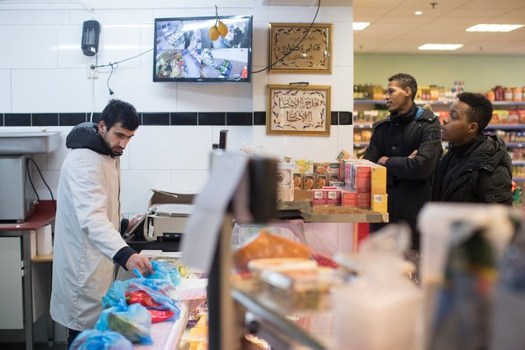
A halal butcher shop in Zeist, the Netherlands. Some fear that the new rules, even if meant for animal protection, will add to tensions at time when anti-Muslim and anti-immigrant sentiment runs high.CreditJasper Juinen for The New York Times

There is only one slaughterhouse in the Netherlands where meat is slaughtered for kosher consumption, and that is done only one day a week. Slagerij Marcus in Amsterdam is the only kosher butcher left in the Netherlands. It supplies the Sal Meyer deli and other kosher restaurants elsewhere in the country.
Motti Rosenzweig, the single slaughterer, or shochet, kills his animals by using an extremely sharp knife to slice through the carotid artery and jugular vein, severing the trachea and esophagus. (Halal slaughtering is performed similarly.)
The new rules dictate that if an animal is not insensitive to pain within 40 seconds of slaughter, based on measures called “induced eyelid reflex” and “cornea reflex,” it must be shot.
“If you shoot it before you slaughter, it’s not kosher at all,” Mr. Rosenzweig said. “They want to shoot it after it’s slaughtered, and that’s where the problem starts. They’re shooting a piece of metal into the brain and they call that stunning.”
“You tell me what’s more humane,” he said.
The new rules also state that the number of animals killed for kosher and halal meat must be limited to the amount “necessary to meet the actual need of the religious communities present in the Netherlands.”
Slagerij Marcus, which relies on exports for 40 percent of its income, may find it difficult to stay in business, said Herman Loonstein, a lawyer for the butcher.
Each side cites scientific evidence to support its slaughtering methods, but measuring the level of suffering an animal experiences is an inexact science at best.
Shimon Cohen, a spokesman on kosher slaughter issues for the European Jewish Congress, said that all parties to the agreement “are to be congratulated” for working out a solution that allows religious slaughter to continue within the guidelines.
But not everyone is satisfied. The Party for the Animals, which first introduced the proposal in the Dutch Parliament seven years ago, said the accord did not go far enough.
“This is just to green wash a bad practice,” the party’s leader, Marianne Thieme, said in a telephone interview. “It’s just trying to make it look better than it is.”
She said she was planning to reintroduce legislation in late January or early February to ban religious slaughter. “It’s not legitimate any longer that treatment of an animal depends on the religious beliefs of its slaughterer,” she said.
Ruben Vis, director of the Organization of Jewish Communities in the Netherlands, said that he had not yet heard that the Party for the Animals intends to renew its legislative effort to ban religious slaughter.
“The Jewish community’s reaction will be, ‘Not again, we’re targeted again,’” he said. “We have worked with the government to find a balance between our expression of freedom of religion and the general principle of the care for animals. I consider it as the best possible outcome.”
A fresh round of changes would only add to the uncertain climate for kosher businesses like the Sal Meyer deli and its supplier, Marcus Slagerij.
Mr. Koppert, the co-owner of the restaurant, said that he’s not sure what he would do if kosher meat became harder to get in the Netherlands. “But we managed so far for 60 years, so we will face the challenge,” he said.
“We will search for alternatives if we have to, but that’s not what we want,” he added. “It would take a big part of the history and the tradition and the sense of community out of the shop.”

Reprinted from the December 31, 2017 website of The NewA version of this article appears in print on January 1, 2018, on Page A4 of the New York edition with the headline: Butchering Laws Pit Religion Against Animal Rights.

Why Kosher Butchers in Western Europe Are Preparing to Close Shop
By Cnaan Liphshiz

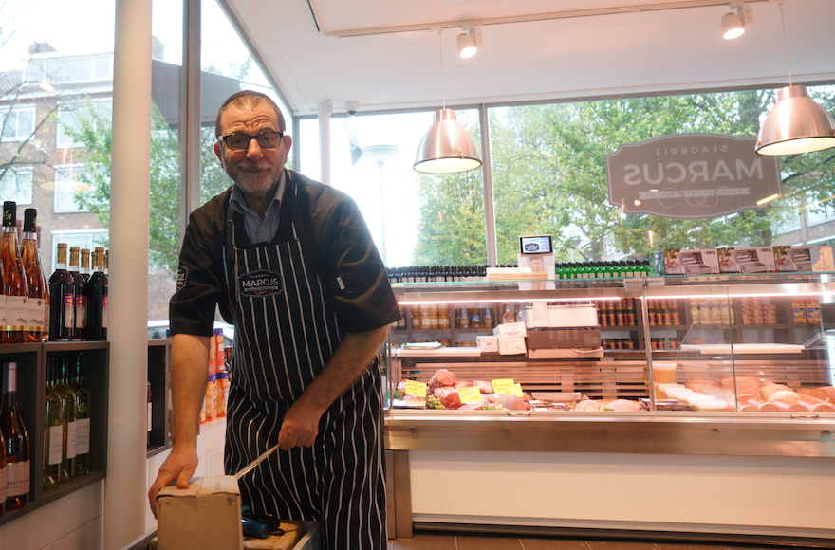
Nissim Guedj unpacking merchandise at a kosher meat shop in Amsterdam, Oct. 26, 2017. (Cnaan Liphshiz)
PARIS (JTA) – When Jerry Levy’s family opened one of the first gourmet kosher meat shops in France, they had some of the country’s best-laid business plans.
Hailing from a long line of Jewish butchers in their native Tunisia, they had the expertise and diligence in 1977 to cater to the changing needs of their growing community, where tens of thousands of Jewish immigrants from North Africa like them were developing both the appetite for quality — and the means to pay for it.
Four decades on, the family’s gambit certainly has paid off: Levy’s meat shop and deli in this city’s 17th district is a communal institution. With a kiss on the cheek, Levy and his teenage son, Maurice, welcome dozens of regulars daily to Boucherie Jerry Levy who swear by the signature foie gras, artisanal charcuterie and assortment of North African salads.
But like other producers of kosher meat in Western Europe, the Levys are no longer certain of the viability of their business. In recent years they have been suffering both from declining revenues due to emigration from France by Jews fearful of jihadist violence and anti-Muslim measures targeting the ritual slaughter of animals.
“I want Maurice to learn a trade because with the meat industry, who knows what tomorrow will bring,” Levy told JTA about his 17-year-old son. “All kosher delis, they will be a thing of the past within one generation either because they’re made illegal, suffocated by anti-kosher regulations or defeated by supermarkets.”
Not all kosher meat producers in France, a country with 500,000 Jews, share Levy’s pessimism. But several of his counterparts in the Netherlands and Belgium do following a fresh wave of restrictive regulations and legislation in those countries, where a total of 90,000 Jews live.
In Holland, the viability of the country’s only kosher slaughterhouse, Slagerij Marcus, and its meat shop are under threat from a new deal signed in July by the government with the Jewish community, according to Slagerij Marcus’ lawyer, Herman Loonstein. The measure limits the production of kosher meat to local consumption, a stipulation that Loonstein says amounts to an export ban that may render the business nonprofitable.
Community representatives say they reached an oral agreement with the government that will head off the export restrictions, but a government spokesman declined to confirm the claim. The spokesman told JTA only that “special circumstances may be taken into account” when it comes to export.
Either way, “The leash keeps getting tighter and tighter, and there are questions on what kind of future there is for the industry,” said Luuk Koole, the longtime manager of Slagerij Marcus.
Iris Jonah is among the hundreds of Dutch Jews who depend on the meat shop and deli; she says it’s her only dependable source for fresh kosher meat. Kosher ground beef is on offer at several Dutch supermarkets, but only at Marcus’ can she find steaks, veal and corned beef for her family of six.
“If they close shop, I don’t know what I’ll do, we’ll be in a big problem,” Jonah told JTA last month. “It’s already tough to lead an observant Jewish lifestyle here as it is without this added complication.”
Jews in the Netherlands could still import kosher meat from France even if Marcus closes. But the quality won’t be the same, according to Nissim Guedj, the France-born store manager at Slagerij Marcus’ meat shop.
“There’s no comparing the far superior quality you get here,” he said of Dutch meat.
A closure could also mean the end for one of Dutch Jewry’s fabled delicacies, a fatty kind of corned beef known as pekelvlees that is produced commercially only at Slagerij Marcus and sold at the iconic Sal Meijer Jewish sandwich shop in Amsterdam.
In Belgium, meanwhile, legislation was passed this year in two of the federal kingdom’s three regions — including Antwerp’s Flemish region, with its predominantly haredi Orthodox Jewish community of 18,000 – that starting in 2019 bans all slaughter performed without first stunning the animal.
Jewish and Muslim religious laws require animals be conscious at the time of their slaughter, a custom that animal welfare activists call cruel and anti-Muslim activists say is barbaric.
Rabbi Pinchas Kornfeld, a communal leader from Antwerp, told JTA on Monday that his congregation is considering an appeal of the legislation in court. Unlike the Dutch community, Antwerp’s predominantly haredi community is so strict that French kashrut certification may not suffice for its leaders, placing the community and its congregants in a potential bind when the bans go into effect.
The current wave of legislation in Belgium and the Netherlands follows an earlier drive to ban ritual slaughter. In the latter, opposition led by the far-right Party for Freedom and animal welfare activists spurred a ban on kosher and halal practices in 2010, but it was overturned by the Dutch Senate in 2012.
In 2013, the Polish parliament also banned the practices, though the prohibition has since been partially overturned.
Slaughter without stunning is now illegal in five European Union member states – Sweden, Denmark, Finland, Lithuania and Slovenia — as well as three other non-EU countries in Western Europe: Norway, Switzerland and Iceland. EU members Austria and Estonia enforce strict supervision of the custom that some Jews there say make it nearly impossible.
Attempts to promote such legislation in France, however, have failed.
Back in Paris, Levy says his immediate concern is with the departure of Jews and not the introduction of laws against their food.
Since 2014, at least 25,000 French Jews have immigrated to Israel alone — a 260 percent increase from the 9,537 who left France for the Jewish state in the previous five years. Levy’s father also left, as did other family members.
And although their departure has made only a small dent in France’s Jewish community overall, their absencehas had a disproportional effect on Levy’s business, he said.
“Those who left are exactly my clientele,” Levy said at his meat shop.
Across the street from his meat shop’s blue facade, two French soldiers toting machine guns stood guard as part of their deployment around Jewish shops and neighborhoods in Paris following the 2015 slaying of four Jews at a kosher supermarket by an Islamist.
As Levy sees it, the French Jews who are leaving are observant individuals with the means to forego the French state’s generous welfare, and who fear for their security following multiple anti-Semitic attacks since 2012 on Jewish schools, supermarkets and other institutions serving mainly affiliated community members.
“The assimilated Jew who eats pork and whose son attends a public school, they’re not likely to leave,” Levy said. “Neither is the poor Jew in social housing. But neither is likely to come to my meat shop anyway.”
French immigration to Israel, which in 2015 peaked at approximately 8,000 newcomers, has subsided, with less than half that number immigrating in the first 10 months of this year. But Levy said that growing initiatives in France targeting kosher meat and the Muslim variant, halal, are compounding his losses and threatening the viability of his businesses.
The problem, he says, are campaigns headed by the National Front party, which opposes what its leader, Marine Le Pen, describes as “Islamist globalization.” Le Pen won 34 percent of the national vote in the first round of the 2016 presidential elections. She ultimately lost to Emmanuel Macron, but it was her best-ever showing.
In recent years, opposition to halal and kosher meat has grown significantly amid awareness-raising efforts by National Front and animal welfare activists who believe that the Jewish and Muslim custom of slaughtering animals without stunning are cruel.
Since 2011, hundreds of butchers in France have adopted a label declaring that their meat only comes from animals that were stunned. Reaching approximately 10 percent of all French meat shops, it was a stunning success of a campaign launched that year by the Vigilance Halal association founded by an anti-halal veterinarian and promoted by National Front.
This has lowered the demand for meat left over from animals that were used for ritual slaughter, Levy said, explaining that kosher rules allow Jews t0 use only 15-20 percent of the cow.
Once a shochet, or certified slaughterer, has taken the kosher bits, the slaughterhouse where he performed the work buys the leftover meat from him. But with demand falling for that product, “slaughterhouses don’t view us as the ideal customers anymore,” Levy said.
“They are paying less than 10 years ago,” he said.
Meanwhile, politicians in France are pressing for the obligatory labeling of meat that does come from animals that were slaughtered without stunning.
In 2013, an advisory committee of the French Senate on the meat industry for the first time made a nonbinding recommendation for such labeling, prompting passionate condemnations by Jewish and Muslim faith leaders.
But even without obligatory labeling, the awareness-raising campaign means that “a non-Jew today wants to buy neither the meat of the cruel Jews nor the terrorist Muslims,” Levy said sarcastically. As pressure mounts, “it will become more and more difficult in the kosher and halal industries.”
Albert Elbaz, a kosher meat shop owner from Aix-en-Provence, near the southern city of Marseille, calls this vision “alarmist.” Jews, he said, “will always eat kosher, and, thank God, we have enough Jews in France.”
But Jews make up less than 1 percent of France’s population of nearly 67 million, meaning that “in reality, the only thing protecting kosher slaughter is the electoral power of the far-larger Muslim population” of 5.7 million, said Levy.
Yet even that protection may be temporary due to the growing acceptance among French Muslims of post-cut stunning — a method in which animals are stunned as their throats are cut.
Post-cut stunning is shunned by most Orthodox certifiers of kosher meat, with the exception of a handful in Austria and the United States. But its acceptability is growing among Muslims, whose rules on ritual slaughter are not as strict as those of Orthodox Judaism.
“The Jewish community seems united in opposing pre-slaughter stunning, while the Muslim community is divided on the question whether stunning should be allowed before halal slaughter,” noted a team of researchers who in 2013 published a report on post-cut stunning.
Technical advances and the Muslim communities’ relative openness mean room for adapting halal slaughter “without compromising its deep and essential meaning,” they added.
That’s bad news for Levy and others in the kosher meat industry, he said.
“The minute the Muslims accept post-cut stunning,” Levy said, “the kosher meat industry is done for.”

Reprinted from the November 27, 2017 dispatch of the JTA (Jewish Telegraphic Agency.)
Struggling to Survive, Congregations Look to
Sell Houses of Worship
By Vivian Wang

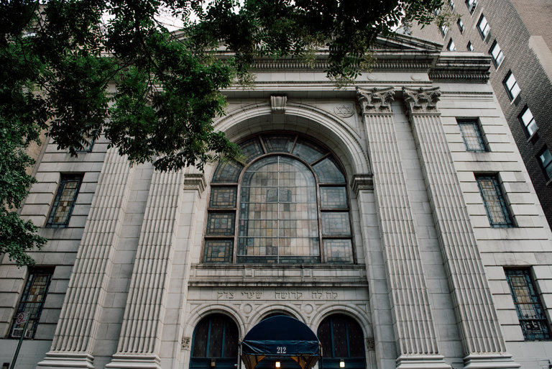
The leaders of Shaare Zedek on the Upper West Side plan to sell the property to a developer for $34 million. The building would be replaced by a 14-story tower, with the synagogue owning and occupying the first three floors. Photo Credit -Vincent Tullo for The New York Times

At first glance, the preservation battle over the nearly century-old synagogue on a tree-lined block of West 93rd Street on the Upper West Side of Manhattan looks familiar, even tired. One group wants to save the stately granite building, emphasizing its history, neoclassical architecture and towering stained glass windows. Another group wants to turn it into a high-rise condominium.
But in a twist, it’s the synagogue that is fighting for the change.
Across the city, financially struggling religious congregations, facing dwindling attendance and shrinking donations, are looking for other sources of revenue. Increasingly they are turning to their most valuable asset: location, location, location (and, in some cases, the air above it).
The state attorney general’s office, whose approval is required for all sales of religious properties in New York, received 165 sale petitions in 2016; so far in 2017, it has received 124. The number of petitions has been increasing in recent years, said Doug Cohen, a spokesman for the office.
In New York City’s fevered real estate market, the pace of such deals — and opposition to them — have become especially frenetic, said Renato Matos, a lawyer who advises religious organizations on real estate transactions.
“There’s a tremendous amount of activity,” Mr. Matos said.
And in some places across the city, neighbors are cobbling together neighborhood associations and legal alliances to fight the proposed sales.
“I’m surprised that the board of trustees and congregation doesn’t really value the history and beauty of the building enough to find a different kind of resolution for the problems they’re facing,” Ronna Blaser, a founder of the West Nineties Neighborhood Coalition, said of the synagogue, Shaare Zedek, which was dedicated in 1923.
Last month, Ms. Blaser and a dozen members of the coalition sat in State Supreme Court in Manhattan for a hearing on Shaare Zedek. (After the attorney general’s office approves a sale, the Supreme Court must weigh in, too.) The synagogue’s leaders plan to sell the property to a developer, who would replace the building with a 14-story condominium tower. The synagogue would own and occupy the first three floors.
Without the deal, valued at $34.3 million, leaders said the synagogue, which was founded in 1837, would fold. The sanctuary is unusable in the winter and summer because it lacks heating and air-conditioning, Michael Firestone, the president of the synagogue, said. And while it seats 1,200 people, only about 80 families attend.
“This is an existential issue,” Mr. Firestone said.
But in court, neighbors in the coalition questioned the synagogue’s motivations, citing its exemption from property taxes. They also worried that the high-rise would bring overcrowding.
Justice Debra James of the State Supreme Court dismissed the neighbors’ complaints, noting that no one who spoke against the plan was affiliated with the synagogue. “Your opposition, as sincere as it might be, is really absolutely irrelevant,” she said.
This situation is playing out again and again across New York City. Upward mobility, suburban growth and the dissolution of traditional ethnic enclaves have all contributed to empty pews, said Robert P. Jones, chief executive of the nonprofit Public Religion Research Institute. Twenty-seven percent of New Yorkers identified as religiously unaffiliated in 2014, compared with 17 percent in 2007, according to the Pew Research Center.
Congregations find themselves defending the development — and even the destruction — of their homes in the name of survival.
That is not to say that worshipers are eager to sell the places where their fathers were bar mitzvahed or their children baptized. The remaining members of Shaare Zedek are fiercely devoted to the space, Rabbi Jonah Geffen said.
“We have congregants who have been coming to this building every Saturday for 50, 60, 70 years. There are people here who are very sad,” Rabbi Geffen said of the sale. But when the congregation voted on the deal last year, the support was unanimous, he added.
At Shaare Zedek, the synagogue’s leaders said Justice James’s ruling may give the synagogue a second life. Mr. Firestone said he hoped that residents of the new condos would find a spiritual home at Shaare Zedek.
And Rabbi Geffen said the emotional process of saying goodbye to the old building was itself an extension of the synagogue’s renewed mission.
“It’s a really extraordinary spiritual practice to go through as a community — to let go of something to which we’re really lovingly attached, for the sake of growth,” he said. “And to go through those things together, that’s part of the reason people are engaged in religious communities anyway.”

Reprinted from the August 6, 2017 website of The New York Times. A version of this article appeared in print on August 7, 2017, on Page A15 of the New York edition.

The Gaza Strip's
Surprising Export
Hamas-ruled Gaza Producing
Kippot for Religious Jews in Israel.

In the heart of the Gaza Strip's Shati refugee camp, machines buzz as Mohammed Abu Shanab's
employees sew small, round pieces of cloth: Jewish kippot for export to Israel.
It may seem an unlikely product to be made in the Palestinian Authority enclave run by the Hamas terror movement, but with unemployment rampant, some in Gaza will take any business they can get.
"The Israelis appreciate our products for their quality and our proximity to their market," Abu Shanab said.
"On the other hand, they fear the crossings will be closed and the delivery of goods will be delayed."
Israel controls all crossings into and out of the Gaza Strip, apart from one bordering Egypt. One terminal on the Israeli border -- Kerem Shalom – is designated for goods.
With about a dozen sewing machines, Abu Shanab's small textile factory, located near the home of Hamas's former leader in Gaza Ismail Haniya, produces other products such as shirts and trousers as well.
Hassan Shehadeh, who employs some 50 workers in a textile factory, says he exports between 5,000 and 10,000 pairs of pants to Israel each month.
"The local market is weak, while trade with Israel is very good," he said.
For Abdel Nasser Awad, director general in the Gaza economy ministry, exporting to Israel is "a purely commercial affair".
"All that we are interested in is boosting our economy and fighting unemployment," he said.
Shehadeh puts it much more bluntly.
"Politics and business are not the same thing," he said. "You can be an enemy in politics, but not in business." The late President of Israel, Shimon Peres, prophesied that economic ties would lead to peace and even a "New Middle East." In Gaza, that seems not to be the case.

Reprinted from the March 10, 2017 email of Arutz Sheva.

Anti-Orthodox is the
New Anti-Semitism
By Eli Steinberg

I’ve recently come to a shocking realization about American society. Over the past few years, it has become increasingly clear that it’s okay to hate Jews. I’m not talking about the abhorrent anti-Semitism of the “alt-right,” where wannabe politicians stoke the flames of bigotry just so that they can get the fleeting feeling of relevance. Thankfully, that sort of thing gets soundly condemned by people of goodwill from across the political and societal spectrums.
But it is apparently socially acceptable to be an open and unabashed anti-Semite — so long as the vitriol is directed at the right kind of Jew.
It certainly isn’t okay to smear and defame “regular” Jews. But if the targets of one’s ire are Orthodox Jews — especially Haredim — the very worst slurs and anti-Semitic tropes are suddenly considered reasonable dialogue and discourse.
In many cases, the same people who rush to condemn the likes of President Trump for the hatred inherent in the “alt-right” perpetuate the same hateful rhetoric they otherwise condemn.
Most distressingly, the perpetrators are often other Jews.
In New Jersey, where I live, this happens time and time again. Do you want to open an Orthodox school of higher education? Residents feel comfortable appealing to their township government, which will join them in fighting to keep you out. It’s a fight that local government will embrace, never mind that they are allying themselves with people who call Jews “dirty,” or “cult” members who are “religious zealots” and “long coat gangsters.”
Under any other circumstance, that’s the sort of blatantly anti-Semitic rhetoric we can expect will be condemned by any decent person. But when the targets are visibly Orthodox Jews, it becomes okay to blame the victim.
Take, for example, a legal battle in Ocean, New Jersey, over the denial of zoning permits for an Orthodox school. The township of Mahwah recently settled a lawsuit over ordinances prohibiting the building of an eruv in their town, but not before a resident addressed the town’s council, deploying a historical smear to insist that the Orthodox had “completely sucked the blood” out of other area towns, and saying they needed to be “removed” from their midst.
You can take a look here and see for yourself:
The council listened to what she had to say in silence, reserving their expressions of indignation for when they were called out.

This is par for the course when Orthodox Jews move into towns that don’t already have a sizable Orthodox population. Of course, there are mountains of excuses for why these people feel they are justified in wanting to keep out the Jews. They blame the effect a large private school population has on the school district’s budget, as well as the accelerated growth that inevitably occurs when Orthodox Jews, who tend to have larger families, settle down somewhere.
These are things that cause real changes to the towns they know and love. And yet, they are deployed as excuses for hate.
You know how I know they are excuses? Because in any other context, you aren’t allowed to call someone a racial slur because you believe the person overtaxes the infrastructure or doesn’t seek the proper permits. In any other context, even if a population were to “gut” the school system, that wouldn’t license racially charged language. None of these things justifies calling a group of people an “infection.”
You know what does cause that, though? Anti-Semitism.
A discussion of anti-Orthodox anti-Semitism would not be complete without addressing the thriving yeshiva community of Lakewood. Lakewood serves as the stated justification for much of this percolating hatred. When Jews move into neighboring towns, they are routinely accused of “blockbusting” — because they pay above market rate for their homes. The mayor of a neighboring town has even called the incoming Jews an “invasion” while using a variation of “some of my best friends are Jews” to deny any animus.
Of course, they all deny that it has anything to do with the fact that their new neighbors are Jews; instead, they say, they just don’t want their town to turn into another Lakewood.
There are challenges in Lakewood for sure, not least of which is a town infrastructure that struggles to keep up with fast-paced development, and a school budget that sees perpetual deficits. But when people express their thoughts about these challenges in their own words, a different sort of tune is easily recognizable.
Take just last week, when the Asbury Park Press hosted a Facebook live discussion with Lakewood School District officials, on the heels of expert reports blaming the rigidness of the school funding formula for the district’s financial woes. The next day, the APP ran a standalone containing nothing but the online and Facebook comments from the Facebook live. You know why they could do that? Because the comments were full of disgusting things. It’s a sign of how much this sort of rhetoric has become normalized and accepted that the APP felt comfortable running it without editorial comment:
“Why isn’t Ocean County addressing the mental illnesses of their community members?” one commenter asked. ”Mass hallucinations, psychosis, delusions of grandeur, anxiety, depression, OCD, ODD, fanatical belief system.”
“This is a joke,” another said. “Everyone knows where the money goes. Nothing will change.”
A similar comment-driven story ran after the Planning Board of neighboring Jackson Township granted legally required approval for the town’s first synagogue. The comments were equally horrifying:
“Another building for a group of people that will not contribute to their community in any way.”
“Just a matter of time before families will be pushed out because the Orthodox have taken over another town.”
“There goes the community, full of isolated tax cheaters that are relentless to force people out of their houses.”
“It’s over people… over, we’re done. Corruption to the core and they make the Mafia look like Boy Scouts.”
It’s baffling that a rational conversation about a synagogue getting approved involves charges that “these people have their own version of traffic safety and laws,” as well as calling it “a real occupation by a fanatical, corrupt, legally hostile religious organization,” and vowing that “the fight has just begun!”
And it’s always “they,” “these people” or “the Orthodox.”
How did this become acceptable? How can such rhetoric have a place in any part of enlightened American society in the year 2018?
These are not fringe lunatics who exist only on Twitter. These are regular Americans in regular communities, who have already come to the realization that we are just beginning to grapple with: that it is socially acceptable to hate certain kinds of Jews.
Imagine any of these sorts of comments being hurled at any other minority; there would be a rightfully indignant reaction of unqualified condemnation.
There’s more than just silence. There is a tacit endorsement of these views — a wink and a nod, if you will — when media keep turning to the agitators of hate as possessing a legitimate point of view, both by quoting them in news stories without comment and by publishing their assertions on opinion pages. That’s even without addressing the inaccuracies of these claims. If I had a nickel for every blatantly false “fact” they’ve allowed these people to run with about Haredi Jews, I’d be able to retire and buy a vacation home in Israel.
The validation doesn’t come from just the media. Worse, direction often comes from liberal — or “enlightened” — Jews, who often join in with or provide cover for those who perpetrate these sorts of attacks. It is a fact, as Mordecai Breuer, professor of Jewish history, wrote, that “Liberal Judaism was always liberal only to its friends.”

Religious Jews apparently don’t count.
There is a challenge every minority faces when it seeks to be accepted by the majority. Minorities always need to overcome the otherization that comes along with their being different. But in a liberal society, it is not acceptable to hate and discriminate on the basis of such differences.

It seems the societal acceptance of Jews has its limits, and this limit tends to be encouraged by other Jews as well. Jews are considered acceptable — and the hatred thereof condemned — when they are the same as everyone else; when the only way to tell they are Jewish is when the bigot posts a star on their photo and says they control the media. That sort of Jew is okay because he allows people to delude themselves into thinking he isn’t all that different after all.
But the Jew who chooses to self-segregate, by devoting his life to a higher power and basing every calculation on His word, the Jew who is visibly different, and who practices his religion differently, well, maybe that’s just not a part of the enlightened bargain.
Maybe, just maybe, instead of rolling their eyes in exasperation when they see Orthodox Jews who are “rocking the boat” by being different, the Jews who lash out at them ought to ask themselves a question, instead of directing their ire at “the Orthodox.”

It’s a question society as a whole is going to have to answer. If a part of society won’t accept Jews who are overtly Jewish, do they really accept Jews at all?

Eli Steinberg lives in Lakewood, New Jersey, with his wife and four children. They are not responsible for his opinions, which he has been putting into words over the past half-decade and have been published across Jewish and general media. You can tweet the hottest of your takes at him at @DraftRyan2016.

The views and opinions expressed in this article are the author’s own and do not necessarily reflect those of the Forward.

Reprinted from the February 7, 2018 website of Forward.com

N.Y. / Region
Jerry Birbach, Leader of Fight to Block Poor Tenants In Queens, Dies at 87
By Sam Roberts

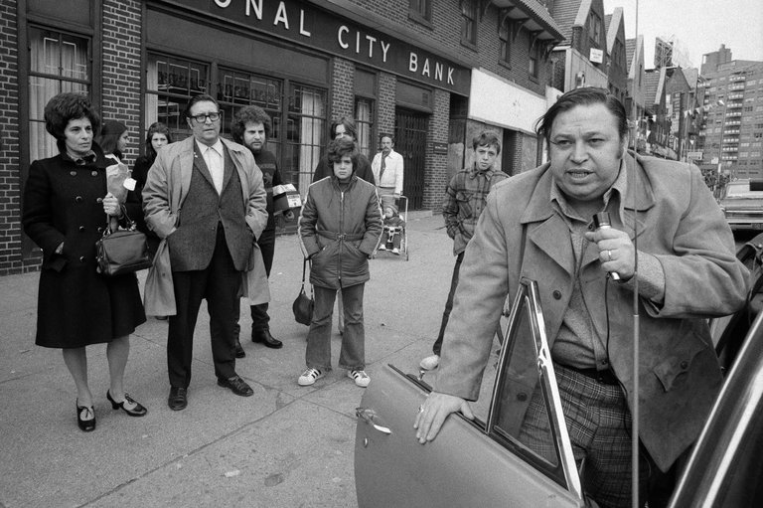

Jerry Birbach, a Queens firebrand whose struggle to block a proposed low-income housing project in his Forest Hills neighborhood in 1972 augured a white middle-class backlash to the liberal urban agenda and helped propel Mario M. Cuomo’s political career, died on Monday in Boca Raton, Fla. He was 87.
The cause was complications of surgery, his grandson Jared S. Pinchasick said.
The planned housing project was a hulking experiment in racial integration that urban planners called scatter-site housing — in this case, three 24-story towers to be occupied mostly by black and Puerto Rican tenants in a largely white, Jewish neighborhood of private homes and garden apartments.
When construction began in 1971, the project galvanized Mr. Birbach and his neighbors and became a national flash point for white resistance in the wake of the civil rights movement and commitments to racial integration.
Mr. Birbach, a paunchy home renovator who lived four blocks from the proposed project’s site, managed the opposition as president of the Forest Hills Residents Association. Mr. Cuomo, a relatively obscure Queens lawyer at the time, was the mediator recruited by Mayor John V. Lindsay’s administration to broker a compromise.

Forest Hills residents protesting Mayor John V. Lindsay’s administration’s plans in 1971 to put three 24-story towers for mostly black and Puerto Rican residents in their largely white, Jewish enclave. Credit Michael Evans/The New York Times

During months of negotiations, some civic leaders preached racial harmony and sought a middle ground. But the project’s opponents resented having to bear the brunt of decisions dictated, as they saw it, by government liberals cloistered in Manhattan.
Mr. Birbach and his followers insisted that they were not racists; rather, they said, they feared that a sudden influx of hundreds of poor tenants would cause a crime wave in what they saw as a stable, middle-class sanctuary.
Mr. Birbach led angry protests (rocks and torches were thrown, but he disavowed sabotage to construction equipment), was arrested at City Hall, hinted at violence and threatened that if the project proceeded, he would lead a mass exodus — and even sell his own home to blacks.
In 1972, Mr. Birbach challenged State Senator Emanuel Gold, who represented Forest Hills, in a Democratic primary but lost. In a debate between the two, Mr. Birbach was “jowly, gruff, unprepared — but effective!” Mr. Cuomo wrote in his book “Forest Hills Diary: The Crisis of Low-Income Housing” (1974).
Mr. Birbach, Mr. Cuomo added, was “a reasonable fellow and, in a lot of ways, likable” but was “obviously responsive to a growing militancy in this town’s middle class.”
The New York City Housing Authority’s decision to build on a vacant patch at 62nd Drive and 108th Street in Forest Hills even reverberated in the 1976 presidential campaign.
Asked about the policy of placing low-income housing in middle-class communities, Jimmy Carter, the Democratic candidate, said he would not force racial integration that would disrupt the “ethnic purity” of a neighborhood. He was denounced for the phrase, which he said was misunderstood, and he apologized.
By the time he was enlisted by City Hall, Mr. Cuomo had already mediated a dispute between the city and residents of Corona, Queens, over construction of a school that would have displaced homeowners. At times, though, with divisions in each camp, it was unclear whom to negotiate with.
Mr. Birbach repeatedly demanded that the project be scaled down to a garden apartment complex for older residents. Ultimately, it was cut nearly in half, from the 840 apartments originally proposed to 432, with 40 percent of the units reserved for the elderly. The towers ended up being 12 stories tall.
The city also adjusted maximum income levels and transformed the project into New York’s first cooperative public low-income housing, in which residents were shareholders.
As a result, 15 years later, 65 percent of the residents were white (compared with 12 percent in all public housing in the city), and 3 percent were receiving public assistance (compared with 27 percent in public housing citywide).
In the next mayoral election, Mr. Cuomo recalled, “none of the candidates argued for integration or dispersal of ghetto residents in middle-class areas.” (That election was won by the Democratic candidate, Abraham D. Beame.)
“The new and safer emphasis was on rehabilitating the ghettos,” he continued. “The clock had been turned back nearly two decades, and many people felt that the impetus for this withdrawal had been provided by Forest Hills.”
In the mayoral race four years later, Mr. Cuomo lost to Edward I. Koch, who had aligned himself with the Forest Hills protesters.
Mr. Birbach sold his Forest Hills home (not to a black buyer), moved to a house a few miles away in Holliswood, and, Mr. Cuomo wrote, “lost 30 pounds, and with it much of his old image.”

From The Archive | Nov. 20, 1971
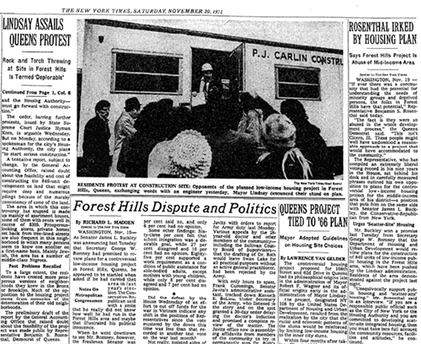
Housing Protest in Forest Hills Termed 'Deplorable' by Mayor

Abraham Joseph Birbach was born on Aug. 5, 1929, in Manhattan to Samuel Birbach, a baker, and the former Esther Silber.
He grew up in the Williamsburg section of Brooklyn and graduated from Eastern District High School. He attended City College, where he studied accounting, but had to leave before graduating to support his family after his father died.
He later renovated and rented out Manhattan brownstones for a living. After the Forest Hills dispute, he completed a graduate degree in urban studies at Queens College.
Besides Mr. Pinchasick, Mr. Birbach is survived by his wife, the former Sherrie Fox; a daughter, Lori Pinchasick; a son, Steven; six other grandchildren; and two great-grandsons.
Mr. Birbach and his wife moved from Queens to Long Island in the 1980s and retired to Florida in 2006.
After a time, Mr. Birbach let bygones be bygones. In 1982, he voted for Mr. Cuomo for governor. He even called him later to ask him to recommend one of his grandchildren to law school. And 15 years after the compromise was struck, he was reflective about a fight that he still considered worth having embarked on.
“Forest Hills was the first time that anyone stood up for the middle class,” he told The New York Times in 1988.
Of the completed housing complex, he said: “It is a very fine development, better than I ever thought it could be. The integrity of the neighborhood has been preserved pretty well, but, you know, we really forced the city to do that.”
Mr. Birbach would regale his grandchildren with stories about his civil disobedience. “He was quite proud that he was full of conviction,” Mr. Pinchasick said, “especially in this day and age, when people are afraid to speak for what they believe in.”
On his 85th birthday, Mr. Birbach hired a bus and took the family on a “This Is Your Life” tour of his past: the site of the Lower East Side tenement, on Attorney Street, where his parents lived when he was born; Public School 50 in Williamsburg (which the comedy team the Ritz Brothers also attended); his brick house in Forest Hills; and the one in Holliswood.
The Forest Hills housing project was not on the itinerary.

Reprinted from the March 1, 2017 website of The New York Times.A version of this article appears in print on March 2, 2017, on Page B7 of the New York edition with the headline: Jerry Birbach, Leader of Battle to Block Poor Tenants in Forest Hills, Is Dead at 87.

Mazal Tov on
Our Tenth Child
By Rabbi Yoseph and Tzippy Vigler

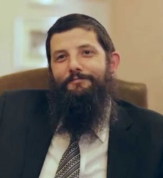

17 years ago when our first child was born, tzu langer yahren, it was still the previous century.
Back then, things were "primitive". I remember saying the Tehillim designated for childbirth, out of an actual paper sefer. Today, I said the designated Tehillim on my handheld device, on an app that knew exactly what I should say.
Back then my wife gave before, during and after childbirth, using coins and notes. Today when she realized she forgot to bring her pushka, she was able to use her credit card on e-donate instead.
Back then, I took a photo of the newborn with a gadget called a camera and showed it to the family a week later once the negative was developed. Today, I had my phone doing it all instantaneously.
Back then, I called everyone on a pay phone to tell them the good news. This time round, everyone somehow already knew, within a minute of birth, before I called them, and were calling me to tell me how beautiful was the video of our baby they already watched.
Yesterday, on our 18th wedding anniversary we had the incredible zechus and thrill of welcoming in our tzenter to be mashlim our minyan of kinderlach kain ayin hara.
Number ten is
just as exciting.
Just as wondrous,
just as miraculous
as number one.
What a thrill, what a bracha, what a gift from Above.
The generation may have advanced but the foundation remains. To nurture, to love, and to care. To be entrusted yet again with G-d's child to raise, to polish and to bring out the shine of another Yiddishe child.
Thank you Aybishter for entrusting us with another precious gift, we should be zoche to nurture yet another Neshama in chinuch to work together in bringing about the Geulah.
Gut Shabbos, Mazal tov and ksiva vachassima tova!

Reprinted from the Parshat Ki Seitzei 5776 email from Mayan Yisroel in Flatbush. Rabbi and Rebbetzin Vigler are co-directors of the shul.

This New Kosher Deli May be Miami’s Hippest Restaurant:
Foodies and hipsters brush elbows with Orthodox Jews in the gritty Wynwood area; uniting them is the stripped-down, traditional Ashkenazi fare of old
By Lucy Cohen
JTA (Jewish Telegraphic Agency

MIAMI (JTA) — The first few weeks in January were meant to be a soft opening for Zak Stern’s new traditional deli. But given the massive following that Stern — better known as Zak the Baker — has garnered for his bakery, things didn’t really turn out as planned.
“We call it a ‘rough opening’ because there’s nothing soft about it,” Stern told JTA on a recent Monday morning as “the deli,” as it is known to differentiate from the bakery, began filling with customers eager to try the house specialties, like a vegetable omelette served with corned beef and aioli, potato kugel and more.
Of course, the instant success of Stern’s deli isn’t too surprising given that Zak the Baker — both his bakery and the man himself — have garnered numerous accolades since setting up shop four years ago. A line of customers, often dozens deep, regularly snakes around the block outside the bakery. The customers wait — sometimes for an hour or more — for his olive-studded loaves of bread, authentic French-style baguettes, croissants and deep-dish quiches.

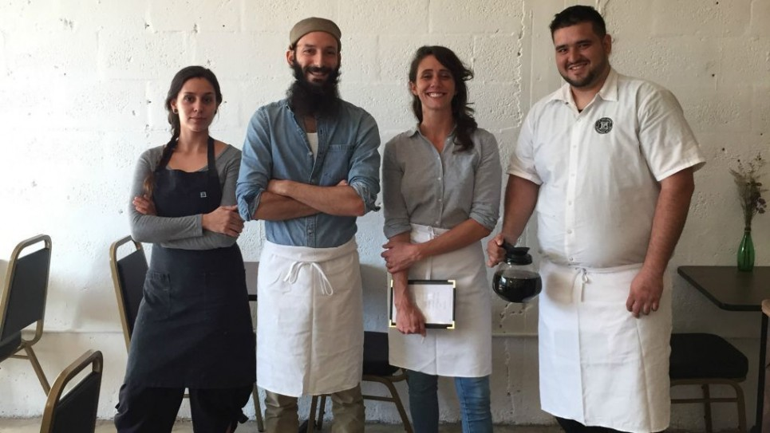

Stern has achieved the seemingly impossible: His eateries are decidedly cool and are popular with Miami’s hipsters and foodie sets. At the same time, however, because they are kosher, they are a destination for observant Jewish Miami residents and visitors, many of whom travel about 20 minutes from the city’s more touristy areas to the Wynwood neighborhood north of downtown.
“Wynwood is one of Miami’s only counterculture areas,” Stern said of the artsy, industrial neighborhood, where many buildings are covered with bright graffiti. And with the opening of the deli, he’s doubled down on it.
“We’ve been able to bridge two worlds,” said Stern, who looks every bit the bearded hipster, but could also pass as a Hasid (which he is not). “It’s hard to find the religious world eating out of their shtetl, and it’s also hard for the nonreligious world, or non-Jewish world, to interact with the religious world. So this kind of gives them the opportunity to sit next to someone religious and fill in the blanks. It’s a beautiful thing.”
“We happen to be certified kosher, but that’s not our identity,” he said. “We’re traditional bakers and now [operate] a traditional Eastern European-style deli, and we happen to be kosher.”

On that recent Monday morning, a couple visiting from New Jersey — she wore a wig; he a baseball cap in place of a kippah — were enjoying an almond croissant and oatmeal cookie at the bar of the bakery, both nodding profusely between bites to communicate that it was worth the nearly 30-minute trip.
Another woman, who didn’t outwardly appear to be religious, had just bought a loaf of cranberry walnut bread at the bakery, having traveled to Miami from her home about an hour away. In fact, she said she often drives 20 minutes to her nearest Whole Foods to procure some wholesale Zak the Baker bread.
“Once you have this, how can you have any other one?” she asked, rhetorically.

The deli’s breakfast platter (Courtesy of Zak the Baker/via JTA)

While chefs like Yotam Ottolenghi in London and Michael Solomonov in Philadelphia have helped make Israeli food “the sexy thing on the block,” Stern thinks it’s time for Ashkenazi food to get the attention it deserves.
“Ashkenazi food has been relegated to bland and boring, and that’s so not true,” he said. “Deli is a soulful, soulful food. I think we can shed some light on it.”
‘You can bake bread everywhere, and it’s accessible to everyone’
Stern, a 31-year-old Florida native, was a pharmacy student when he decided to switch gears to bread baking.
“I was a 22-year-old in pharmacy school learning all these complicated things but I was craving basic fundamental life skills; bread making is such a symbol of that,” he said. “You can bake bread everywhere, and it’s accessible to everyone.”
Stern quit school and went to Europe to apprentice on farms. He started with agriculture and then “zeroed in on farms with bread and cheese,” he said.
When he returned to Miami in 2012, Stern launched a bread business out of his friend’s North Miami garage, selling to farmer’s markets and the like. Word of mouth sent the business soaring.
“The market quickly drew a line, until the point where I was selling out of bread in less than an hour,” he said.
At one point, a woman Stern met while working at a goat cheese farm in northern Israel asked to come to Miami and apprentice for his burgeoning business. Fast forward three years and that woman, Batsheva, is now his wife and mother to his two children. He refers to her on social media as #myreligiouswife.
As a suburban kid who grew up Reform, marrying a religious woman from a small village in Israel is practically intermarriage, Stern said, noting how differently the two were raised. She is the reason he started keeping Shabbat, “so she wouldn’t be alone,” he said.
And it was Batsheva who introduced him to kashrut; because of her strict observance, he made his bakery kosher. And in the years since, Stern has learned all the intricacies of running a kosher business.
Being kosher, he said, brings a real authenticity to the deli, in particular.
“If we’re going to do it legit, it’s got to be kosher, that’s part of it,” he said.
European delis that catered to our great-grandparents would not have served melted cheese on their sandwiches — nor would they have sold expensive sandwiches as big as your head, he said. They also would have cured their meats in house, as Stern does.
“The community here in Miami, I think, needed something that’s wholesome and soulful,” he said. “Delis aren’t fancy or expensive, as a lot of kosher restaurants are. Deli food is the working man’s food.”
For now, the menu at the deli is limited as the kitchen undergoes renovation. (The spot where the deli stands was once the bakery, which was forced to move to a larger location down the street when the wholesale business picked up.)
‘Delis aren’t fancy or expensive, as a lot of kosher restaurants are. Deli food is the working man’s food’
But Stern said there were a couple of things he knew the deli needed to have as soon as they launched — “a really good pickled vegetable plate with a pickled green tomato, a non-mayonnaisey cole slaw and house-made corned beef,” he said. (Stern’s corned beef is made on the premises in a seven-day brine.)
There’s also smoked fish — and, unlike New York delis, which mostly use whitefish, they use the blue runner native to Florida.
Stern is particularly excited for the upcoming deli case with traditional Eastern European foods like yapchik (a kugel with flanken), p’tcha (jellied calves’ feet) and kishke (stuffed intestine), which people can take to go.
“Whatever obscure Ashkenazi food that you can’t find anywhere, we’ll have here,” he said.
But for those outside the Miami area, you’re going to need to travel to try it out.
“I’m totally uninterested in creating an empire,” he said. “Zak the Baker doesn’t need to be in New York, it doesn’t mean to be in LA. There’s plenty of room for other bearded bakers.”

Reprinted from the February 7, 2017 email of the Times of Israel.

